! OfficiabPublication of ALOA—An International Association of Security Professionals

www-.aloa.ori

Merritt Perkins, RL

follows the history of GM sidebar locks from 1935-1990.



**PLUS!** Greg Perry, CML, CPS attacks an aluminum-glass storefront job featuring Uon Duprin 33 rim exit deuices.

5k&*&****#*&&&****#*3_UJ(3Jrp 3Q3

Breck H. Camp CML POBox47070 Atlanta GA 30362-0070

**llso in this Issue:** Picksets Part 2 of 2, Email tiquette, the latest on Hutomotiue Legislation, oard Nomination information, and More!

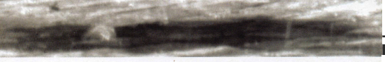

*An American Original*

Building on its 90-year tradition of quality,

systems help make your life easier, and

ingenuity and locksmith support, American Lock today delivers your security needs as never before.

Numerous innovations in padlock construction — including solid body locks, double-ball locking mechanisms, serviceable components and high-security cover plates — long ago established American Lock as the industry's security leader.

Unmatched services such as Make-to-Order capability, Lock Express™, key charting,

your operation more profitable.

**The best is yet to come.**

Now American brings renewed vigor to locksmiths everywhere, aided by joining forces with Master Lock during the past year ... with additional resources focused on developing new products and value-added services to further help you grow your business.

Contact your distributor for details as they unfold.

|  |  |  |
| --- | --- | --- |
| custom marking, locksmith training, merchandising displays and other time- |  | _ _ |
|  | 1 |  |
|  | c |  |
|  | .. . . .. r | The Locksmith's Lock® |
|  | © 2004 American Lock Company | |

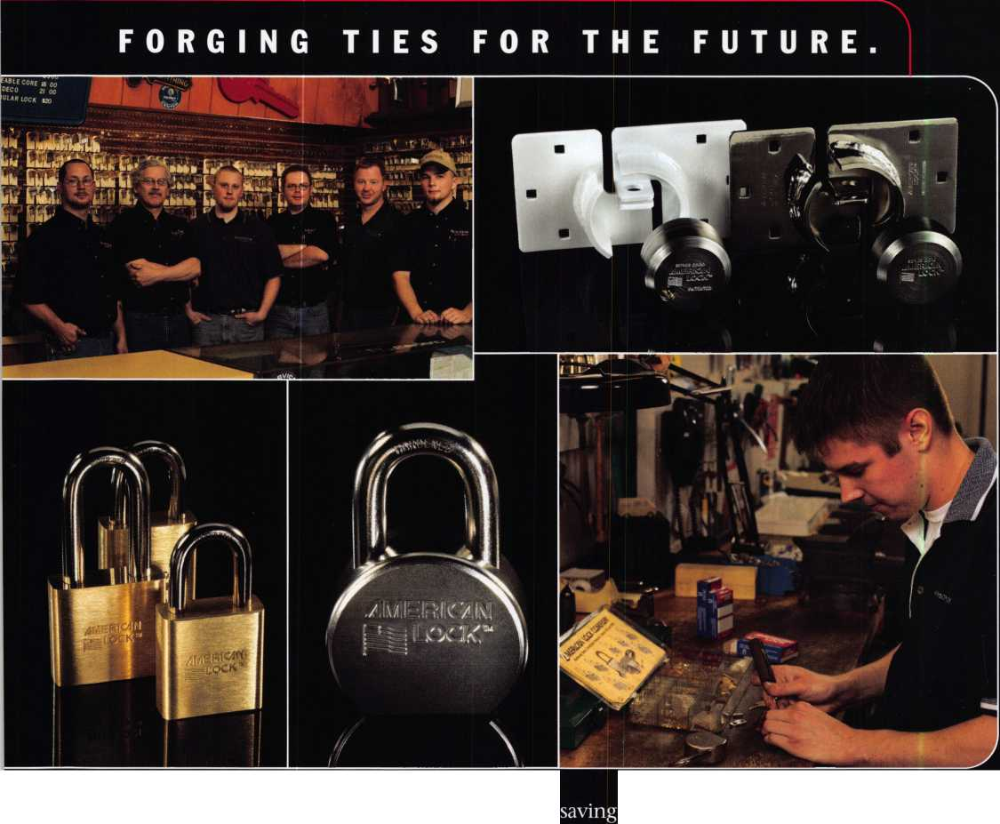

*Safetech Oieite beautiful Lexinqton, Kentucky!*

*March (y—t2, 200S  
Hyatt Regency, Lexinyten /(/*

T>

, ML r^ey Mac, keeping up with the latest the industry has to offer has never  
been more important for us safe technicians. Let me tell ya, you gotta stay  
aware of what today's top safe distributors and manufacturers are putting out  
there. It's crucial to making a humdinger of a purchasing decision, buddy.  
And another thing, time is of the essence when it comes to education. New  
things pop up every day, Daddy-O, and that makes top-notch safe classes  
as good as gold. The only chance to get world-class education and meet  
with the industry's top distributors and manufacturers is the SAFETECH  
Convention and Trade Show. Boy, is it swell! SAFETECH 2005 offers you  
a chance to meet with potential customers and bolster business in ways  
you never thought possible. Discover the safes of tomorrow! Gee whiz,  
jump and jive your way into Safetech 2005, and you'll be part of our  
knock 'em, sock 'em show of all shows!!

The j^afe and Vault Technicians Hssociataion  
Cjonnention and Trade 0hom

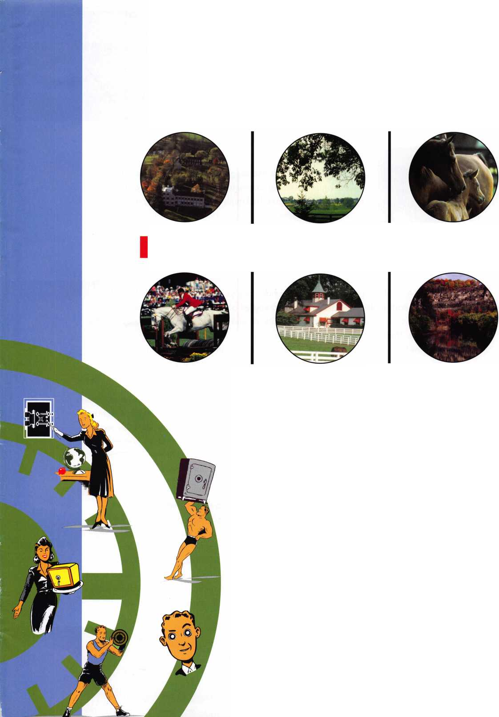

presidentia

**viewpoint**

Dear Members,

I recently returned from attending the MINK (Missouri, Iowa,  
Nebraska, and Kansas) Convention in Omaha, NE. I would like to  
thank the host Nebraska Locksmith Association president, Bernard  
Dobesh, and vice-president Eugene Hanson, for their tremendous  
hospitality. They also hold the same positions with the Nebraska  
Chapter of ALOA.

Bernard contacted me many months ago and invited me to speak at

the banquet. He asked me to address the issue of why young locksmiths should belong  
to ALOA, explaining that his association has many young people who don't feel the  
need to participate in the associations. I prepared a speech on the topic and, when it  
came time to deliver, I looked into the audience and there were no young people at the  
banquet. They just didn't show up! I gave the talk anyway and explained that it is our  
responsibility to bring young people into the industry and motivate them into getting the  
education and building the relationships that are needed so that our industry can survive  
and be passed on.

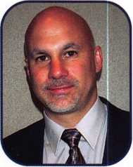

This month's topic is automotive locks, one that is dear to my heart. ALOA is an important part of the group that is working to ensure that we can get proprietary information from the OEMs (Original Equipment Manufarcturers), thus allowing us to continue this sector of our business. Since the National Automotive Service Task Force met at our convention in Baltimore, the OEMs have a much clearer idea of who locksmiths are and what our capabilities are. Now, we just need access to the information and we are much closer to devising ways to get it!

I just had an interesting experience with car key making that I'd like to share. I was called out to a new automotive training school to duplicate and program keys for 8 transponder-equipped vehicles. When I arrived at the school, I was introduced to "half cars"... essentially comprised of only the front half of the vehicle. They have fully-functional engines with modified exhausts but are primarily used for diagnostics. They also have full vehicle identification numbers, which was good because I had to get PIN codes for two Chrysler products. So, there I was, working alongside students with diagnostic equipment much like mine. I still charged "full" price for "half" a car.

Sincerely,

William L. Young, CML, CPS

Keynotes • November 2004



**The RLOR**

**Conuention**

**and Security Expo July 17-24, 2005**

SLUEET

Get Ready for RLOR 2005,

a powerful resource to explore innouation and form industry alliances. This year we’ue thouyht of everything from an exciting location, comfort­able accommodations and a conuention center that is equipped to handle your euery need.

Located just minutes from downtown  
Chicago, Rosemont, Illinois is the  
perfect “business village”, designed specifically  
to make your stay convenient, comfortable  
and above all, successful!

The 49th Rnnual RLOR Convention and Security Expo  
offers top-notch classes, workshops, networking  
opportunities and cutting-edge technology.

Rnd don’t miss out on the fine dining and enter-  
tainment options that Chicago has to offer. Shop  
at the world-famous Magnificent Mile. Eat at  
Morton’s of Chicago or Harry Caray’s Italian  
Restaurant. Uisit the Navy Pier or catch a ball  
game. The options are endless when you register  
today for the single-most important event in  
the locksmithing industry.

Baby, you know you want to yo!



**RLOR 2005**

Sweet Home Chicago

**features**

AUTOMOTIVE 2004

10

A Brief History of GM Sidebar Locks

In 1935, GM introduced sidebar locks with six tumblers  
and four bitting depths: 0.250, 0.225, 0.200, ). 175  
(measured from the bottom of the cut to the bottom of the  
key). The spacing was 0.107 from shoulder to center of  
the first cut and 0.093 between cuts. There was only one

keyway. by Merritt Perkins, RL

**14**

The Job the Other Guys Didn't Want

A local door company bid a job, only to have their  
installer turn it down. So Greg Perry accepted the chal-  
lenge of this Von Duprin 3327 aluminum and glass

storefront door, by Greg Perry, CML, CPS

22

**30**

What's in Your Pickset?: Turners and Spinners

(Pt. 2 of "Bread and Butter Picks" from October 2004)

The variety of products available and the fact that  
each locksmith has specific preferences shows us  
that the tiny tension wrench is indeed worthy of  
some further investigation Eric Costtey, crl

Before You Push the "Send" Button

As security professionals, it is our responsibility to send a  
positive e-mail message to our customers (or potential cus-  
tomers). Don't push that "send" button until you are sure  
that your message represents a first-rate image for your

busi neSS. by Claire Choen, CML

**Departments**

|  |  |
| --- | --- |
| Presidential C( | Vendor 8 |
| Viewpoint 2 ^ | Dre 9 |
| c | ossified 36 |
| Executive 5 |  |
|  | >sociate |
|  | embers 38 |
| Applicants 6 |  |
| Le | gislative 40 |

N

**Get** Your  
Board  
Nomination  
Form on  
Page 42

**'•W-T**

/

|  |  |
| --- | --- |
| r |  |
| AD INDEX | |
| American Lock | Inside Cover |
| CCL | 7 |
| Strattec | 21 |
| Keedex | 25 |
| Hinge Doctor | 27 |
| Turn 10 | 35 |
| Lockman Tools | 36 |
| A&B | 36 |
| Hickok | Back Cover |
| L | A |

Visit our website at [www.aloa.org](http://www.aloa.org)

**executive**

Volume 50, Issue 10



Additional contact information for the ALOA Board and most Keynotes authors is available through "Locksmith Search'" on the ALOA Web site- [www.aloa.org](http://www.aloa.org) or by contacting the ALOA office at 3003 Live Oak Street; Dallas, TX 75204; (800)532-2562; FAX (214)827-1810; e-mail [aloa@aloa.org](mailto:aloa@aloa.org).

|  |  |
| --- | --- |
| Publications Manager  Betty Henderson | [betty@aloa.org](mailto:betty@aloa.org) |
| Technical Editor  David Lowell, CML, CMST | [david@aloa.org](mailto:david@aloa.org) |
| Editorial Advisor  John Cannon, CML | jcannonl @cox.net |
| Advertising Sales  Kim Hammond | voice: 817-645-6778 |
| Executive Director  Charles W. Gibson, Jr., CAE. | Fax: 817-645-7599 e-mail: [adsales@aloa.org](mailto:adsales@aloa.org)  [charlie@aloa.org](mailto:charlie@aloa.org) |

Associate Executive Director

David Lowell, CML, CMST [david@aloa.org](mailto:david@aloa.org)

Convention & Meetings Manager

Jo Anne Mims [joanne@aloa.org](mailto:joanne@aloa.org)

Operations/Membership Manager

Mary May [mary@aloa.org](mailto:mary@aloa.org)

Government Relations Manager

Paul Kanitra [paul@aloa.org](mailto:paul@aloa.org)

IT Operations Manager

Greg Jackson [greg@aloa.org](mailto:greg@aloa.org)

Comptroller Kathy J. Romo

Membership Coordinator Shelly Jett

Convention & Meetings Assistant Karen Lyons PRP/Education Coordinator Hope Rodriguez

Accounting Coordinator Melinda Miller

Mail Room Coordinator Kevin Wesley

Publications Coordinator Bryan Dease

Executive Assistant Sue Langford

Receptionist Wendy Wilder

Contributors

Jerome Andrews, CML Paul Chandler, CRL Claire Cohen, CML Brian Costley, CML, CMST Eric Costley, CRL

Ray D'Adamo, CML Billy Edwards, CML Dan Graffeo, CRL,CMST Jim Hancock, CPL Jeff Nunberg, CML, CMST

Randy Simpson, CML, CPP Robert Stafford, CML Dave Thielen, CML Greg Perry, CML,CPS

Tom Seroogy

Charles Stephenson, CPS

Dennis Watanabe, CML, CMST

Mission Statement: The Associated Locksmiths of America, Inc. is dedicated to enhancing the professionalism, education and ethics among locksmiths and those in related sectors of the physical security industry. With approximately 10,000 members in the United States, Canada and the freeworld, ALOA is poised to help members obtain the knowledge, the strength, and the confidence to perform their role in the physical security field with pride and dignity. But it is only through active involvement and participation that ALOA can fully achieve its potential—and can help members to achieve theirs.

Policies: Keynotes® is the official publication of the Associated Locksmiths of America, Inc. (ALOA). Keynotes® acts as a moderator without approving, disapproving, or guaranteeing the validity or accuracy of any data, claim, or opinion appearing under a byline or obtained or quoted from an acknowl­edged source. The opinions expressed by the authors do not necessarily reflect the official views of ALOA. Also, appearance of advertisements and new products or service information does not constitute an endorsement of products or services featured by the Association. The Association does not accept responsibility for the inaccuracy of any data, claim, or opinion appearing in this publication, due to typographical errors on the part of the authors, Association staff or its agents.

Editor's Note: This publication is designed to provide accurate and authoritative information in regard to the subject matter covered. It is provided and disseminated with the understanding that the publisher is not engaged in rendering legal or other professional services. If legal advice and other expert assistance is required, the services of a competent professional should be sought.

Authors' Payment: Payment for eligible submissions to Keynotes will be based on the following criteria: topic, time spent and past contributions. Authors who regularly submit to Keynotes® are generally paid a higher rate. The latter is especially true of authors who write to fit specific editorial needs and submit said copy by Keynotes® deadlines. As a general guideline: Average payment for a 750 word, business or 'light' technical article would be $200. Payment for a 1500 word article involving significantly higher time and research efforts would be $400.

Payment will not be offered for articles submitted by ALOA employees or members of the ALOA Board of Directors (unless material is of a technical nature), nor for articles submitted by a company that promote that company's products or services. ALOA reserves the right not to pay for articles sub­mitted by an individual(s) that promote a particular company's products or services.

Disclaimer: The Associated Locksmiths of America, Inc., (ALOA), reserves the right to refuse any article for any reason. Additionally, ALOA reserves the right to edit, amend or modify any article submitted for publication in order to preserve technical accuracy, clarity, fairness or grammatical cor­rectness. ALOA will make the best efforts to notify the author of any changes. The extent of ALOA's liability for any article or information contained therein will be a notice of correction or retraction in the next possible issue.

Keynotes® (ISSN 0277 0792) is published monthly except for the combined June/July issue by The Associated Locksmiths of America, Inc., 3003 Live Oak St., Dallas, TX 75204-6186. Telephone: (214) 827-1701; FAX (214) 827-1810; e-mail [aloa@aloa.org](mailto:aloa@aloa.org). Subscription rates for members—$ 15.00 per year. Periodical class postage paid at Dallas, Texas. POSTMASTER: Send address changes to: Keynotes, 3003 Live Oak St., Dallas, TX 75204-6186. © Copyright 2003, All rights reserved. No part of the contents may be reproduced or reprinted in any form without prior written permission of the publisher.

President

William L. Young, CML  
(610)647-5042  
[president@aloa.org](mailto:president@aloa.org)

Secretary

John Soderland, CML, CMST  
(414) 327-5625  
[secretary@aloa.org](mailto:secretary@aloa.org)

Directors, Northeast

Robert E. Mock

(856) 863-0710  
ned i rector@a loa. org

Peter Sarailian, CRL  
(973)890-9797  
ned i rector@a loa. org

Vernon Kelley, CPL

(609) 771-3126  
nedirector@aloa. org

Directors, Southeast

Tom Gillingham, Jr., CML, CPS

(615)264-0747  
sedirector@aloa. org

Ken Kupferman, CPL

(813)961-5784

[sedirector@aloa.org](mailto:sedirector@aloa.org)

Director, North Central

Mark E. Blum, CML, CPS  
(517) 482-5809  
.[ncdirector@alod.org](mailto:ncdirector@alod.org);

Director, South Central

CD Lipscomb, CML, CPS  
(903)874-3522  
scdirector@aloa .org

Directors, Southwest

Gordon R. Racine, CML  
(719) 384-4707  
[swdirector@aloa.org](mailto:swdirector@aloa.org)

Julie McCluney, CRL  
(714)636-5652  
[swdireetor@aloa.org](mailto:swdireetor@aloa.org)

Director, Northwest

Jim Jeffries, CPS  
(208)743-1101  
[nwdirector@aloa.org](mailto:nwdirector@aloa.org)

Director, European

Hans Mejlshede, CML  
(453)539-3939  
eurdirecfor@aloa. org

Director, Asian

Joe J. Lee, CRL  
(215)289-2404  
asiandirector@aloa .org

Director, Associate

Paul M. Justen  
(800)333-6953  
asdirector@aloa. org

Trustees

[frustees@aloa.org](mailto:frustees@aloa.org)

Randy Simpson, CML

(281)2405959

John j. Greenan, CML, CPS  
(773) 486.2030

Past Presidents

2001-2003 Randy Simpson, CML  
1999-2001 John Greenan, CML, CPS  
1997-1999 Dallas C. Brooks  
1995-1997 David Lowell, CML, CMST  
1993-1995 Breck Camp, CML  
1991-1993 Henry Printz, CML  
1989-1991 Evelyn Wersonick, CML, CPS  
1987-1989 Leonard Passarello, CPL  
1985-1987 Joe Jackman, CML  
1983-1985 Stanley Haney, CPL  
1981-1983 Louis LaGreco, CPL  
1979-1981 John Kerr, RL  
1977-1979 Clifford Cox, CML  
1974-1977 Charles Hetherington  
1972-1974 Gene Laughridge  
19701972 William Dutcher, RL  
1968-1970 Constant Maffey, RL  
1966-1968 Harold Edelstein, RL  
1964-1966 William Meacham  
1962-1964 Robert Rackliffe, CPL  
19601962 Edwin Toepfer, RL  
1956-1960 Ernest Johannesen



Keynotes • November, 2004

**applicants**

for membership

|  |  |  |  |  |  |  |
| --- | --- | --- | --- | --- | --- | --- |
| AL |  | FL | Wheaton | NE |  | VA |

Calera

Shane Green

Oneonta

Jesus G. Barragan

Sponsor: Ronald L. Fowler CRL

Alma

James H. Teas Jr

Sponsor: Clifford D. Lipscomb CML, CPS Eureka Springs

William Croft

Sponsor: Jeanette McDonald Harrisson

Charles J. Sippel Jr

Sponsor: Clifford D. Lipscomb CML, CPS

Chandler

Ruben A. Hernandez

Sponsor: Enrique B. Olivares

Michael A. Smith

Sponsor: Enrique B. Olivares

Jesse Riley

Sponsor: Enrique B. Olivares Gilbert

Richard C. Panek

Sponsor: Enrique B. Olivares

Santa Rosa

Ralph C. Bell

Sponsor: Craig B. Hackney

Englewood

Mark Edwards

Sponsor: Gordon R. Racine CML

Deland

Kenneth Palmer

Haines City

Michael Adams Jr

Sponsor: Michael S. Adams  
Holly Hill

James Hamilton

Middleburg

Adrien C. Romano

Sponsor: Daemien C. Romano  
North Palm Beach

Michael E. Bie

Tampa

Christopher K. Doten

Sponsor: Austin R. Curry II,  
CML

Alpharetta

Russell M. Gravitt

Sponsor: Dale R. Mattice Atlanta

Paul F. Argento

Sponsor: Kenny R. Carroll

Cherokee

LeRoy Nelson

Sponsor: Phillip D. Squibb

Chicago

Rickey L. McDonald

John W. Miller

Sponsor: William T. Beranek

Indianapolis

Mark D. Culver

Sponsor: Jim Williams CRL

Randolph

Timothy J. O'Toole

Sponsor: Barry L. McMenimon CRL

Omaha

Jerald V. Schroeder

Sponsor: Elvis D. Hammer- schmidt CPL

Bath

J Mark Kulikowski

Sponsor: Mark W. Fuller CPL

Norman

Travis Scott

Bethesda

Michael B. Albright

Sponsor: Michael C. Olson CRL

Ann Arbor

Timothy Sarver

Sponsor: Todd A. Phillips CRL Livonia

R Todd Ippolito

Sponsor: Claude A. Hensley

Fayetteville

Jackie Bright

Sponsor: Granger L. Marley CML

Timothy Noszek

Sponsor: Granger L. Marley CML Kittrell

Martha A. Sears

North Bend

Kevin Fellows

Portland

Douglas Frieze

Bethlehem

Karen J. Brice

Sponsor: James T. Brice CRL

John W. Rendle

Sponsor: Donald A. O'Shall CPL

Dallas

Douglas Benkelman

Kerrville

Ricky Raney

Sponsor: James L. Hancock CPL

Arlington

Arthur Romero

Sponsor: Michael B. Groves Charlottesville

Travis Sprouse

Sponsor: Christopher Meccia CRL

Fredericksburg

Larry Dockery

Sponsor: Michael B. Groves Spotsylvania

William C. Salvas

Sponsor: Michael C. Olson CRL

Des Moines

Matthew D. Messerer

Sponsor: Michael D. Tagart

Pleasant Prairie

Andrew Oniszczuk

Sponsor: Christopher C. Olson CRL

Canada

Orillia, ON

Rick B. Sadler

Sponsor: Charles S. Doubrough

Ulaanbaatar TUV

Altangerel Ijilseg

Sponsor: Ross A. Logan RL

These applicants are scheduled for clearance as members of ALOA. The names are published for member review and comment within 30 days of this Keynotes issue date,  
respectively, to ensure applicants meet standards of ALOA's Code of Ethics. Protests, if any, should be addressed to the Membership Department and must be signed. Active  
Membership applicants (a) have worked in the industry two or more years. Allied Membership (AL) applicants are not locksmiths, but work in a security-related field.

Apprentice Membership (AP) applicants have worked in the industry less than two years.

**6**

Keynotes • November 2004

T^mmMobWihO^

**Lock all of- your checked luggage**

**Prevents surreptitious entry**

**AT AIRPORTS...**

**Search**

TM

iRVPWr-

Know Who Searched Your Belongings

SearchAlert

Re-settable combination

LOCKS ARE STRONGLY RECOMMENDED FOR ALL CHECKED LUGGAGE

CCL Security Products new SearchAlert re-settable combination lock was designed with

A SECURITY FEATURE WHICH ALLOWS TSA AGENTS, USING A SECURED ACCESS DEVICE, TO OPEN THE

SearchAlert lock without destroying the lock.

Available in 4 colors:

Black: Model #7400PSB 1 white: Model #7400PW § Bright Nickel: Model #74O0BN H Pewter: Model #7400PTR

I SearchAlert, U.S. Patents H Pending

The new SearchAlert Security window changes color from Green to Red when the TSA secured

ACCESS DEVICE IS USED TO OPEN THE LOCK, OR WHEN AN UNAUTHORIZED PERSON HAS OPENED THE LOCK USING A COUNTERFEIT OPENING DEVICE.

Travelers will now know when their SearchAlert

LOCKS HAVE BEEN OPENED, AND WHETHER THEIR BAGS HAVE BEEN SEARCHED BY A TSA AGENT, OR VIOLATED BY AN UNKNOWN PERSON.

PRESTOLOCK® 8c PRESTOSEAL"'

USE FOR ALL YOUR CARRY-ONS AND EVERYWHERE ELSE YOU TRAVEL

Security Products

301 West Hintz Road • Wheeling, IL 60090 Telephone: 800.733.8588 • Fax: 847.537.1881 [www.cclsecurity.com](http://www.cclsecurity.com)

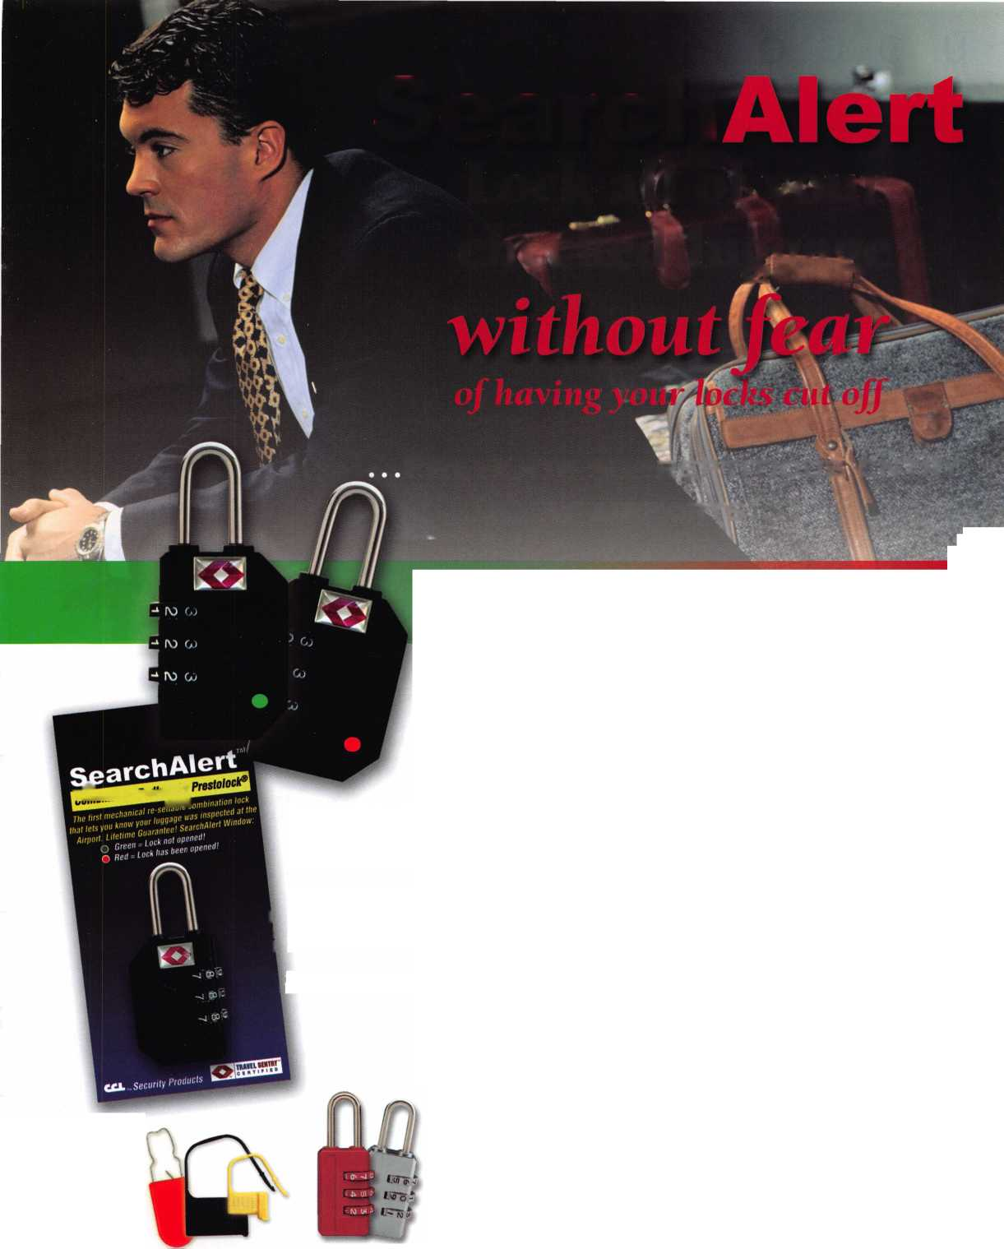

**upcoming**

**events**

|  |  |  |  |  |
| --- | --- | --- | --- | --- |
| 10 New York Master Locksmiths' Assoc | 3 Ohio Val | ley Chapter of ALOA | 3 Minnesota Chapter of ALOA 20 | Oklahoma Master Locksmith Assn. |
| Monthly Meeting | Monthly | Meeting | Regular Meeting, Dinner 6:00 PM, | Basic electronics education |
| NYC/Long Island Area | Ryan's St | sakhouse | Meeting 7:00 PM, Program: MN | seminar and membership meeting. |
| 718 274-6930 | Middleto | n, Ohio | Sales Tax or Homeland Security | Holiday Inn Select in Tulsa. |
|  | 513-464 | •1299 |  | 405-919-0235 |

Ohio Valley Chapter of ALOA Monthly Meeting Ryan's Steakhouse Middleton, Ohio 513-464-1299

nnesota nual Bai > Meet n

Mi

Annual Bt

No

Chapter of ALOA

nquet, Dinner 6:00 PM,

ng

New York Master Locksmiths' Assoc. Monthly Meeting NYC/Long Island Area 718 274-6930

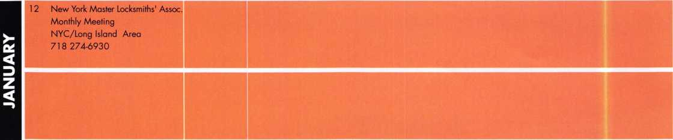

UPCOMING ACE CLASSES UPCOMING PRP SITTINGS

|  |  |  |
| --- | --- | --- |
| 11/13/2004 | Atlanta, GA • Georgia Chapter of ALOA • Kevin Wilson, CML,CPS 770-279-1161 • PRP Prep Class | 11/11/2004 |
| 11/13/2004 | Detroit, Ml • Locksmith Security Association • Robert Nobel, CPL 810-385-9329 • Combination Lock Servicing w/L-24 PRP | 11/13/2004 |
| 11/13/2004 | Kalamazoo, Ml • Western Michigan Locksmith Assn.  R. Paul Bentley, CPL 269-327-8400 | 11/13/2004 |
|  | Complete Door & Door Closers w/L-05 PRP | 11/14/2004 |
| 11/20/2004 | St Louis, MO • Bi-State Chapter of ALOA • Robert Theobold 314-340-6801 • Alternate Entry Techniques | 11/20/2004 |
| 12/4/2004 | Birmingham, AL • Alabama Locksmiths Association • DLee Schofield 334-832-4920 • Simplex Unican Certification | 11/28/2004 |
| 1/5-16/2005 | Kalamazoo, Michigan • West Michigan Locksmiths Assn  R. Paul Bentley, CPL 269-327-8400 • Small Format 1C w/L-38 PRP  Large Format 1C w/L-39 PRP | 12/9/2004 |
| 2/12/2005 | Detroit, Michigan • Locksmiths Security Association  Robert C. Nobel, CPL 810-385-9329  Complete Door and Door Closers w/L-05 PRP | 2/26/2005  2/27/2005 |
| 2/19-20/2005 | Kalamazoo, Michigan • West Michigan Locksmiths Association  R. Paul Bentley, CPL 269-327-8400  Motorcycle Locksmithing w/L-22 PRP |
| 3/5/2005 |
| 2/25-27/2005 | Minneapolis, Minnesota • Minnesota Chapter of ALOA •  Dana Lee, CML 612-9684500 • 5 ACE Classes | 3/12/2005 |
| 3/3-6/2005 | Somerset, New Jersey • Master Locksmiths of New Jersey Annual Convention & Trade Show • Bill Timmann, CML, 908-839-3135  21 Ace Classes | 7/22/2005  10/09/2005 |
| 3/19-20/2005 | Kalamazoo, Michigan • West Michigan Locksmiths Association  R. Paul Bentley, CPL 269-327-8400  Combination Lock Manipulation (2 days) |
|  |
|  |
| 4/28-30/2005 | Denver, CO • Central & Southern Colorado Locksmiths Assn  Gordon Racine, CML 719-3844707 • 9 Ace Classes |  |
| 7/17-24/2005 | Rosemont(Chicago), Illinois • ALOA 49th Annual Convention & Security Expo • David Lowell, CML,CMST 800-532-2562 xl8  70 full day classes • 35 half day classes & evening seminars |  |

Thursday 8:30am • Dallas, TX • ALOA • Hope Rodriguez  
800-532-2562x30

Saturday 8:00am • Cary, NC • NC Locksmiths Assn  
Granger L. Marley, CML 919-859-6060

Saturday 6:00pm • Robinsonville, MS • TN Organization Of Locksmths  
Jim Wiedman, CPL 615-837-1264

Sunday 1:00pm • Robinsonville, MS • Tennessee Organization of  
Locksmiths • Jim Weidman, CPL 615-837-1264  
Saturday 8:00am • Atlanta, GA • Georgia Chapter of ALOA Kevin  
Wilson, CML,CPS 770-279-1161

Sunday 8:00am • Ellicott City, GA • Clark Security Products  
Joan Emrick 619-718-7308

Thursday 8:30am • Dallas, TX • ALOA Hope Rodriguez  
800-532-2562x30

Saturday • 9:00am Roseville, Ml • Locksmith Security Assn  
Robert Noble, CPL 810-385-9329

Sunday 9:00am • Denver, CO • Central & Southern Colorado  
Locksmiths Assn • Gordon Racine, CML 719-384-4707  
Saturday 8:00am • Somerset, NJ • MLANJ 200 • Bill Timmann, CML  
908-839-3135

Saturday 8:00am • Lexington, KY • SAFETECH 2005  
Hope Rodriguez 800-532-2562x30

Friday 6:00pm • Rosemont, IL ALOA 2005 • Hope Rodriguez  
800-532-2562x30

Sunday 9:00am • Orlando, FL • SERLAC 2005 • James Barnhardt, RL  
813-689-5979

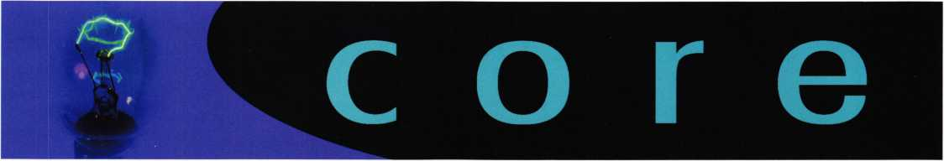

NEW CERTIFICATIONS

"The following member achieved the level of CRL on February 28, 2004 and was inadvertently left out of the new certification list for that month."

Jeffery J. Hobert, CRL

ASIS Security Conference

The final attendance figures for the ASIS International 50th anniversary conven­tion here in Dallas was 19,001. This exceeded previous forecasts of 17,000.

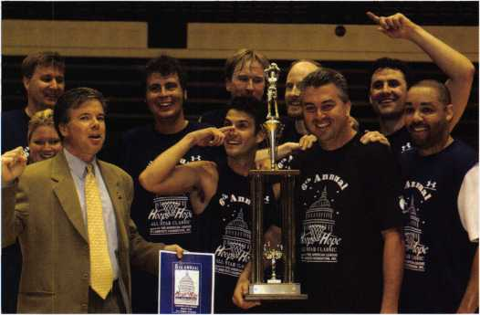

Lobbyists vs. Congress

The ALOA Legislative Action Network was represented at the sixth annual Hoops for Hope charity basketball game, at George Washington University's Smith Center. This year, Hoops for Hope raised $33,000 for Hill Help and Horton's Kids charities. To date, the game has raised more than $150,000 for these two charities that provide mentoring to children in Wellington Park in Southeast D.C.

In a surprising upset, the Lobbyists beat the Congressmen. ALOA Government Relations Manager, Paul Kanitra is pictured above with the winning team.

In Memory

ALOA member Charles Kevin Foster, age 44, passed away at his home on September 9, 2004. He began his life-long career as a locksmith through a school training program. He started working at the age of 15 for Wing's Locksmith Shop in Montgomery, Alabama. In June 1990, Charles started his own business, Ace Locksmithing Service. In January of 2001, he and his customers joined Montgomery Lock and Key.

Cherishing his memory are long-time friend and wife, Kathy (a past-employee at Wing's Locksmith and Office Manager for Ace Locksmith), two teen-aged sons, Chris and Rocky, the city of Tallahassee, Alabama, and stepson, David pate of Panama City Beach, Florida.

Charles was well known and well liked, with a very fine reputation as "The Ace" locksmith. He serviced clients of large companies along with city and state build­ings in Montgomery, Alabama and surrounding counties. He was also a member of the Alabama Locksmith Association, serving as Treasurer from 1994-1996. In his spare time, he also enjoyed coaching his sons in baseball.

North Carolina Locksmiths Association Elects New Officers

The North Carolina Locksmiths Association, Inc. held their election of officers for the years 2003-2004:

President 1 st Vice President 2nd Vice President Treasurer Asst. Treasurer Sgt. at Arms Asst. Sgt. at Arms Board Members

Secretary

Steve Bright  
Gwyn Campbell  
Hosie King  
Jeanette Busse  
Georgia Pope  
Jeff Stone

Robert Derruisseaux

Shane Ellison  
Mike McCord  
Paul Atkinson  
Reid Skinner  
Adrian Busse  
Jerry Lewis

Debbie Derruisseaux

Lock Busted by a Bic®

Cycle enthusiast, Benjamin Running recently posted video on his website about his Kryptonite bike lock. He was amazed at the ease with which a person can open the lock using an ordinary ballpoint pen.

Kryptonite spokeswoman Donna Tocci conceded the locks1 newly found vulnera­bility. "It’s anything with a tubular cylinder, not just our locks," she said.

Bike advocates said other cylindrical locks are vulnerable, including some models of the OnGuard lock.

On September 22, 2004 Kryptonite announced that the company is offering free product exchanges to all consumers who are concerned about the security of their current Kryptonite tubular cylinder locks.

At no charge to them, consumers will be able to exchange their current Kryptonite tubular cylinder lock for a Kryptonite non-tubular cylinder lock. Kryptonite will begin exchanging products within a few weeks as it accelerates product avail­ability.

"At Kryptonite, we understand the responsibility that comes with being the market leader. Since we learned last week about the possibility of compromising some of the industry's tubular cylinder locks, we have been working diligently to devise the best and most responsible solution to address the concerns of consumers and to meet the needs of our distributors and retailers," said Steve Down, General Manager of Kryptonite. "We decided to simplify and expand our planned prod­uct upgrade program so that we could expedite the process for consumers and eliminate any lingering doubt in their minds about their locks. Standing by our customers is the responsible thing to do for those who rely on our security prod­ucts to keep their valuables safe."

To participate in the free product exchange offer, consumers can visit the compa­ny's Web site at [www.kryptonitelock.com](http://www.kryptonitelock.com) for registration instructions. As part of this effort, Kryptonite will initiate a swap program through direct communication with all of its distributors and retailers.

GM Sidebar Locks From the Beginning

By: Merritt L. Perkins, RL

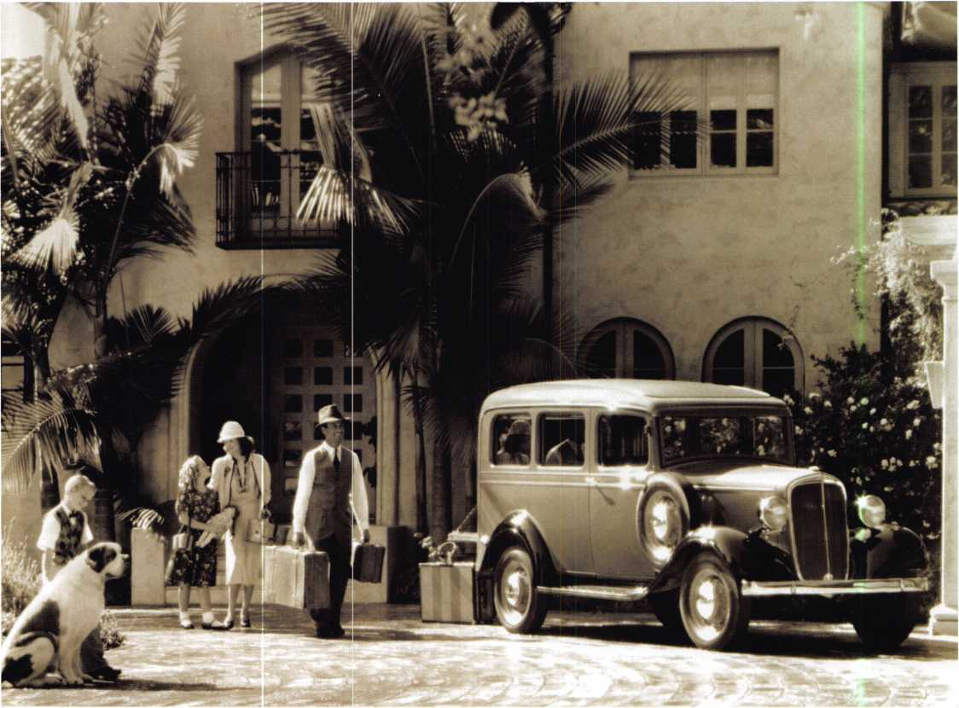

In 1935, GM introduced their sidebar locks with six tumblers and four bit­ting depths: 0.250”, 0.225”, 0.200” and 0.175” from the bottom of the cut to the bottom of the key. The spacing was 0.107” from shoulder to center of the first cut and 0.093” between cuts. There was only one keyway.

Keynotes • November 2004

The primary key had an octagon-shaped head and operat­ed the ignition and door locks while the secondary key had a pear-shaped head and operated the glove and trunk locks. The glove compartment lock had five disk tumblers and was not a sidebar lock. There was a set of 64 tryout keys on a beaded chain with depths half way between the stan­dard bitting depths that was used to unlock the doors and trunk in addition to ignition lock servicing in the case of a lost key. When a tryout key was found that turned the ignition cylinder to the removal position the plug could be removed and a key could be made from the code stamped on the side of the plug.

In the 1967 the locks were changed to slightly different spacing of cuts and depths and a fifth depth was added. The spacing was 0.109” from shoulder to center of first cut and .0925” between the centers of the cuts. The five depths were 0.248”, 0.223”, 0.198”, 0.173”, and 0.148”. The primary key with a rectangular head operated the igni­tion and door and the secondary key with an oval head operated the glove compartment and trunk locks. Each key had a different cross section and its own codes which changed every year. The key cross section and the keyway is identified by a letter (A, B, C, D, E, H, J or K) stamped on the key near the bow. A set of tryout keys for each keyway is much larger and took longer to try than the old set of 64 tryout keys and two sets (one for the primary keyway & one for the secondary keyway) were needed each year.

In 1977 another change was made. The primary key oper­ated only the ignition and the secondary key now operated the door, trunk and glove compartment. The code number was stamped on a small insert that was partly punched out so that it could be knocked out and given to the new owner. The hole in the insert was so small that the insert had to be knocked out in order for the key to fit on a stan­dard size key ring. Replacement key blanks had the knock out already punched out when received. Later keys had a plastic or rubber cover over the bow.

The operation of the GM sidebar lock is unique. The key is inserted in the lock with the bittings down—just the opposite of a pin tumbler lock. When the correct key is inserted it raises the tumblers to the correct height causing the V-shaped notches in the side of the H-shaped tumblers

to line up with the sidebar so that the sidebar can drop into the notches bringing it flush with the surface of the plug, allowing the plug to turn. Two light springs press the sidebar against the tumblers while the tumbler springs are strong enough to force the tumblers down, raising the side- bar out of the notch in the tumbler and causing it to extend outside the surface of the plug into a cutout in the case so that the plug will not turn.

To pick the sidebar door or trunk lock while on the vehi­cle, insert diagonal cutters to depress the unit shutter, cut the cap and tear it off. The cap is crimped all around over the front of the die cast lock case. Replacement caps have four tabs that can be bent to hold it to the lock case. Remove the unit shutter and two springs and drill a small hole (3/32” to 118” in diameter) in the 9 o’clock position into the plug at the left side to give access to the end of the side bar. Be careful when the drill breaks through so as not to damage the side bar or spring. Insert a small rod or wire (about 0.030” in diameter) with a tapered end through the hole and past the sidebar spring to push the sidebar against the tumblers while you use a lock pick to push down on the tumblers until the side bar enters the notches in the tumblers. Now, you should be able to turn the plug slightly until the wire hits the side of the notch in the case. Remove the wire and turn the plug to unlock.

You may be able to use a small paper clip for the wire.

If the lock has been removed from the vehicle, you can drill a small hole in the side of the case to put pressure on the side bar without removing the cap. If you wish, you can fill the holes you drilled with an aluminum-filled epoxy material.

You may be able to determine the combination of the lock by using a tool that can measure the distance from the top of the keyway to the top of the tumbler while the lock is held in the picked condition and pressure is exerted on the sidebar.

Replacement sidebar tumblers have the depth number stamped on the tumbler where it is visible through the key way. If the tumblers have been replaced you may be able to find the combination by looking in the key way.

You need a lifter to move the tumblers in front so the number on the tumbler behind can be seen. The numbers will be upside down.

Keynotes • November 2004

li

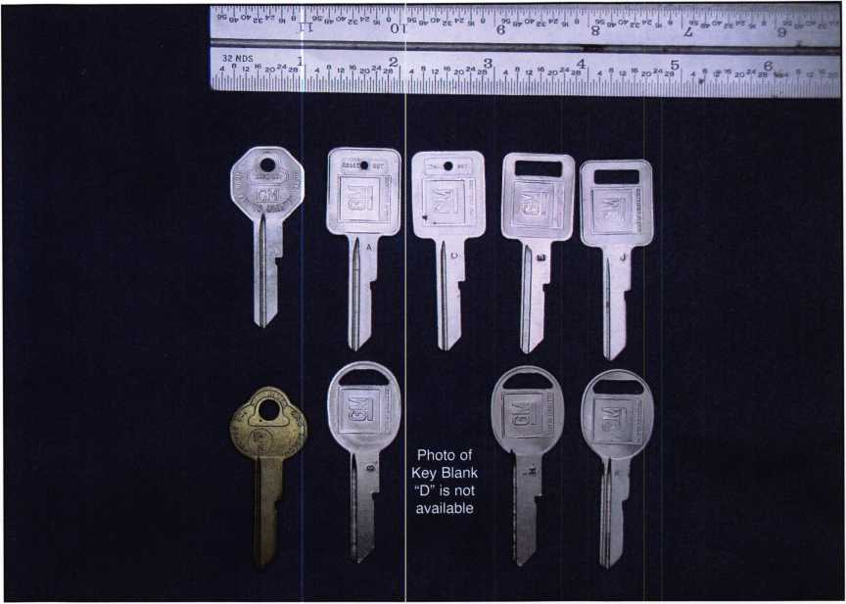

GM sidebar locks can be impressioned. Here is an overview of one method. To impression a sidebar lock, the key needs to be a loose fit in the keyway. Scrape out the grooves and narrow the blade so that the key can rock back and fourth. The end of a slim taper file can be used to scrape out the grooves. If you have a key machine available m ake cuts of the shallowest depth on the edge of the blade in all bitting positions. Insert the key in the lock and apply pressure to the right to bind the sidebar against the tumblers and move the key up and down a few times. Repeat this several times then look for impression marks on the edge of the blade. These are bright shiny rectangular marks where the edge of the tumbler pressed against the edge of the key blade. The tumblers are 0.030” thick so the shiny mark will be 0.030” wide across the edge of the key blade. It will be easier to get impression marks if the key blade is narrow because there is not so much metal to move. When you are sure of the impression mark, cut to the next depth in that position and continue with the procedure until the key turns and the lock is unlocked. If you make a cut too deep, the key may still mark in that position and you will need to start over. Once you have impressioned a working key that fits all of

the locks that it is supposed to fit, cut a key by code and give the code key to the customer.

In the 1990s a Vehicle Anti-Theft System (VATS) was introduced that incorporated a resistor pellet in the key bow. These key blanks are more expensive and there are several different resistor values. In addition to the key blanks, an interrogator is required to determine the correct resistor value to use. Customers are surprised at the cost of replacement keys on the newer systems and this requires some education and salesmanship on the locksmiths’ part to explain why the keys cost so much more.

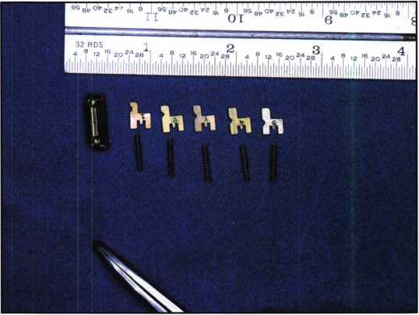

**2**

Keynotes • November 2004

**Available at**

org

Just  
a Few

of Our Titles •••

Learn About Basic Electricity 29.95

Spacing and Depths, vol 1 19.95

Spacing and Depths, vol 2 19.95

Filing for Dollars 29.95

Antique Padlocks 29.95

VATS Made Simple (Revised) 29.95

Guide to Transponders 79.00

2000 Transponder Update 45.00

Bread & Butter 85.00

Locks and Lockmakers of America 1 9.95

Learn About Electronic Locking Devices 29.95

The Best of Locksmithing, vol 1 19.95

Logical Lock Diagnostics 29.99

How to Pick Lever Locks 1 9.95

Fundamentals of Master Keying 55.00

Guide to Electronic Locksmithing 39.95

Security Solutions Locksmith Marketing Program 89.95

The Ultimate Techtips Collection 39.95

PRP Resource Guide 25.00

Locksmithing from Apprentice

to Master 27.00

Wafer Lock Reading 19.95

Door Lock Encyclopedia 39.95

Lock Repair Manual 14.95

Interchangeable Core Cylinders 34.95

Picking & Impressioning 45.00

The Lure of the Lock 29.95

High Security Safes, vol 1 175.00

High Security Safes, vol 2 175.00

Safeman's Guide, vol 13 9.95

Safe Deposit Depth and Space Manual 99.00

Safe Technician's Reference Manual 155.00

Gun Safes 110.00

Modern Safe Opening 59.95

Dave McOmie on Vault Doors, vol 1, Bank Vaults 110.00

Dave McOmie on Vault Doors, vol 2, Fire and Plate Vaults 1 10.00

Modern Safe Locks 95.00

Drilling Safes 95.00

Safe Deposit Box Service 39.95

Foreign Car Impressioning Book 29.95

Impressioning Ford and GM Side Bar Locks 29.95

Automotive Lock Servicing Update #1: GM 10-Cut Locks 29.95

Automotive Lock Servicing Update #2: GM 10-Cut Locks 29.95

Automotive Lock Servicing Update #3: GM 8-Cut Locks 29.95

GM Locks: Perfect for the Beginning Locksmith! 29.95

Ford Locks: Pin Tumbler and Ten-Cut Systems 29.95

Chrysler Pin Tumbler Locks 29.95

Chrysler Double-Bitted Locks 29.95

Toyota Split-Tumbler Locks 29.95

Basic Door Panel Servicing 29.95

Advanced Door Panel Servicing 29.95

Motorcycles on CD 99.00

The Guide to Motorcycles 99.00

Japanese High Security Auto Servicing 29.95

Revised GM Steering Column Course 1 15.00

Foreign & Domestic Auto Service 69.95

Auto Lock Service 14.95

The Sieveking Auto Key Guide & Illustrated Cross Reference 27.00

Servicing Interchangeable Cores—Sargent 25.00

Servicing interchangeable Cores—Arrow, Best,

Eagle, Falcon, and Lockwood 25.00

The Ultimate CCTV Program on CD Rom 595.00

**Visit the new-and-improved ALOA Store to view more available titles.  
Place your order online or by phone today!  
[www.aloa.org](http://www.aloa.org) • (214) 827-1701 • Please allow 3-4 weeks for delivery.**

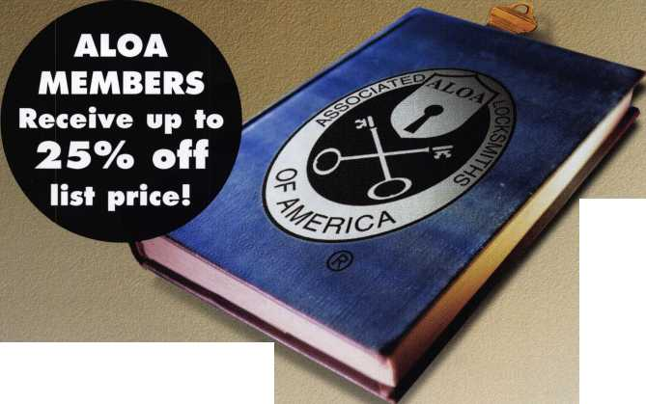

The Job the Other Guys Didn’t Want

by Greg Perry, CML, CPS



Why do I get the jobs no  
one else wants? A local  
door company bid this  
job, only to have their  
installer turn down the  
install. They called us and  
asked if we could install 2  
sets of Von Duprin 3327  
surface vertical rod exit  
devices on two pair of  
aluminum and glass store-  
front doors. We told them  
that we could, yes but we  
were not interested in hav-  
ing our name attached to  
the job. There were two  
reasons for this. First,  
surface-mounted vertical  
rod exit devices violate  
both Title 24 of the  
California Handicap  
Access Code and the  
Federal Americans with  
Disabilities Act (ADA).  
Second, our experience  
has been that vertical-rod  
devices require more  
maintenance then  
rim-mounted devices.  
Because our company  
strives to keep the overall  
cost down for our cus-  
tomers, we are seldom low  
bidder on a job. Instead,

**14**

Keynotes • November 2004

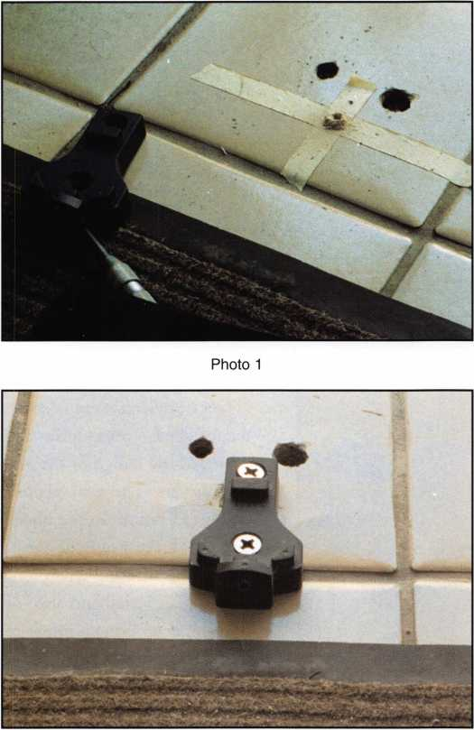

Photo 3

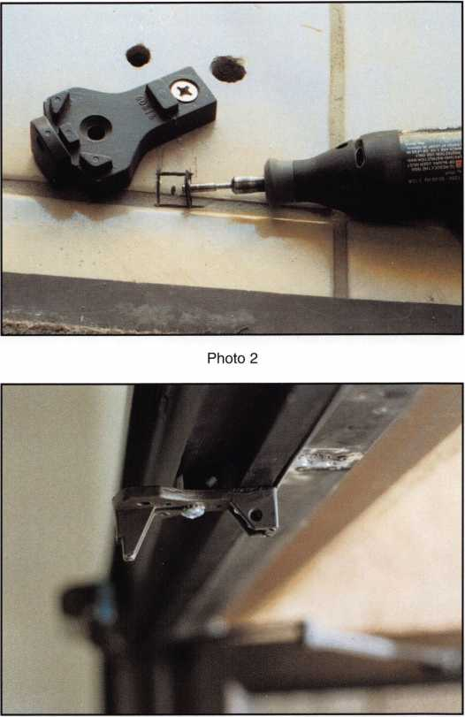

Photo 4

we stress using quality equipment and materials for a lower long-term cost including future repairs. After explaining our viewpoint, the door company rep asked us how we would have bid the job. Using Von Duprin 33 rim devices with a mullion, was our answer. A few weeks later, the door company delivered the hardware as recommended and asked when we planned on installing it.

The doors originally had Adams Rite hook bolts with 3-point locking systems. At some points, flush bolts were installed instead of the 3-point locking system. Since the hook bolts were mounted above the original push bars, we left the locks in place and turned the cylinders upside down in preparation to install some blank cylinders. Next, we installed the mullions. The first step in this process was

to install the bottom mounting bracket. We applied mask­ing tape (seen in photo 1) to help prevent cracking the tile as we drilled our first hole. The location of the second hole (seen in photo 2) was on the edge of a tile. We used a Dremel tool with a reinforced fiberglass disk to cut the tile prior to drilling. (Photo 3 shows the bracket installed.) Finally, we installed the upper bracket. This required either cutting the doorstop or a spacer. We chose to cut the spacer with an angle bracket for support. The spacer (seen in photo 4) was one of the plastic fifth-hole spacer blocks supplied with LCN door closers. The bracket (seen in photo 3) was held in place with Vise Grips while holes for rivets were drilled. Finally, the mullion was cut to length and placed on the brackets.

Keynotes • November 2004

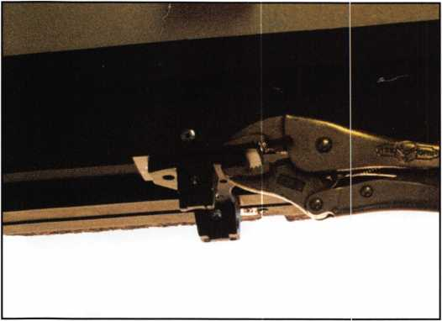

Photo 5

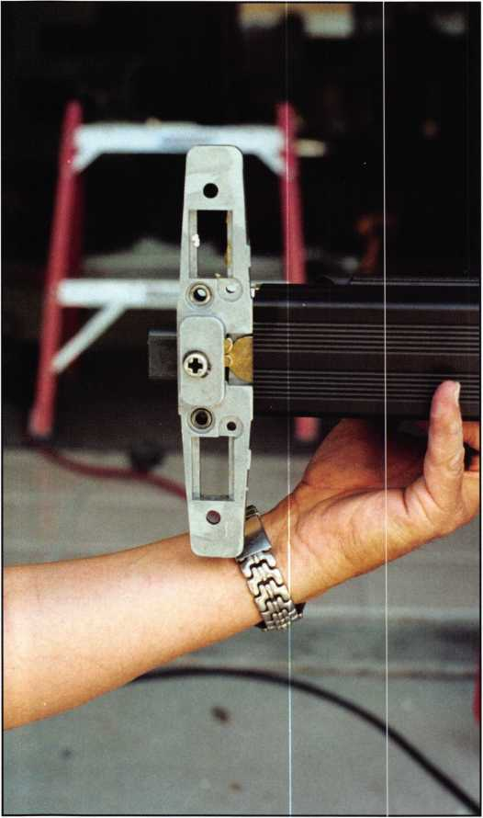

Photo 7

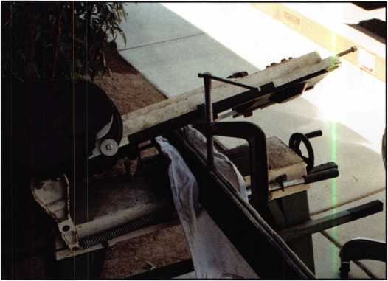

Photo 6

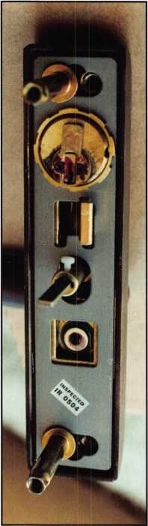

Photo 8

The exit devices were next to be installed. Von Duprin changed the design of the 33 rim devices. The new version requires a cutout in the door even for an exit only device. (Keep this in mind when quoting an install and also remember to bring a router to make the cutout.) The back­side of the center case can be seen in photo 7. It shows the area sticking out from the back of the case. Personally, I prefer the old-style center case with the flat back as it only needed 2 screw holes for mounting.

The trim has also changed. A lever is now available to meet ADA guidelines. The back­side (seen in photos 8 and 9) show the operation. The trim as shown is a NL (“night latch” or storeroom) function. This means the lock is always locked from the outside. If you desire a TP (“classroom”) function, turn the cam of the mortise cylinder 180 degrees on the plug. This keeps the

S

**6**

Keynotes • November 2004



***Visit our Website on****[www.stamcctv.com](http://www.stamcctv.com)*

**THE COMPLETE**

**CCTV PROGRAM ON CD-ROM  
FOR STAFF TRAINING AND**

**PRODUCTIVITY ENHANCEMENT**

STAM Insight has been  
developed to enhance CCTV  
skills and productivity with  
many different uses.

It Productivity

Vt System Drawing O Estimation I# CCTV Training • CCTV Reference Vi Sales/Demo V# System Design Vi Staff Evaluation

CCTV Content

CCTV C&ofarofS

Tod

Qr&ung

Pre-T&t

|  |  |  |
| --- | --- | --- |
|  |  |  |
| INTO ft* ATI. | MOM KM ATE | ULTIMATE |

**Sold in Over 50 Countries**



3003 Live Oak Street  
Dallas,Texas 75204

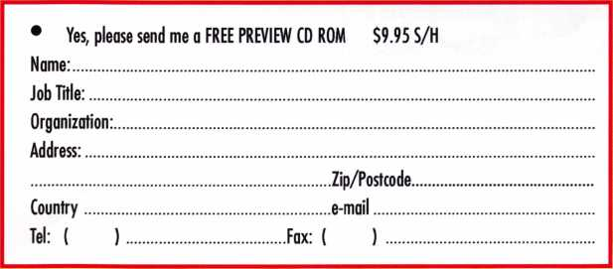

COPYRIGHT © 1996 Security Training and Marketing Pty Ltd.  
All rights reserved ACN 057 006 541

*mm*

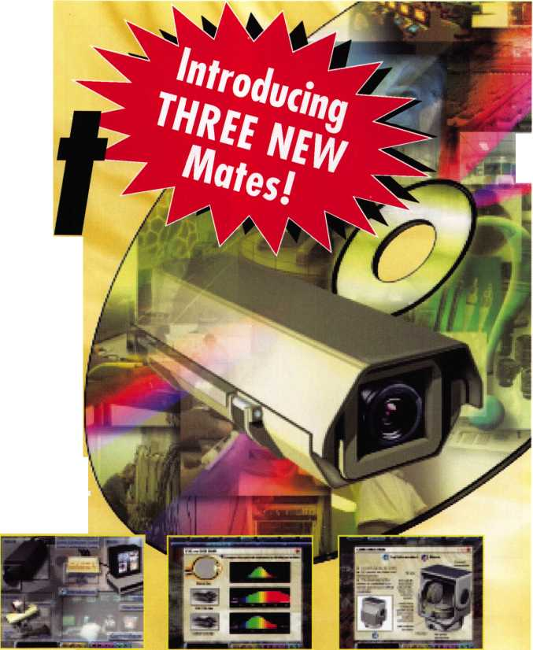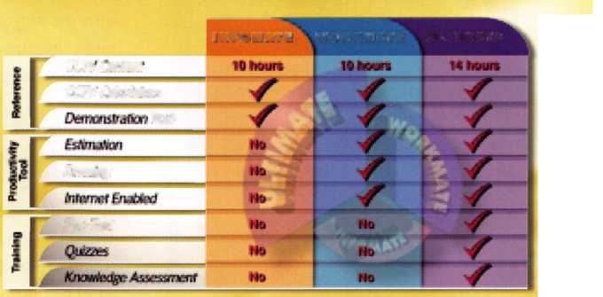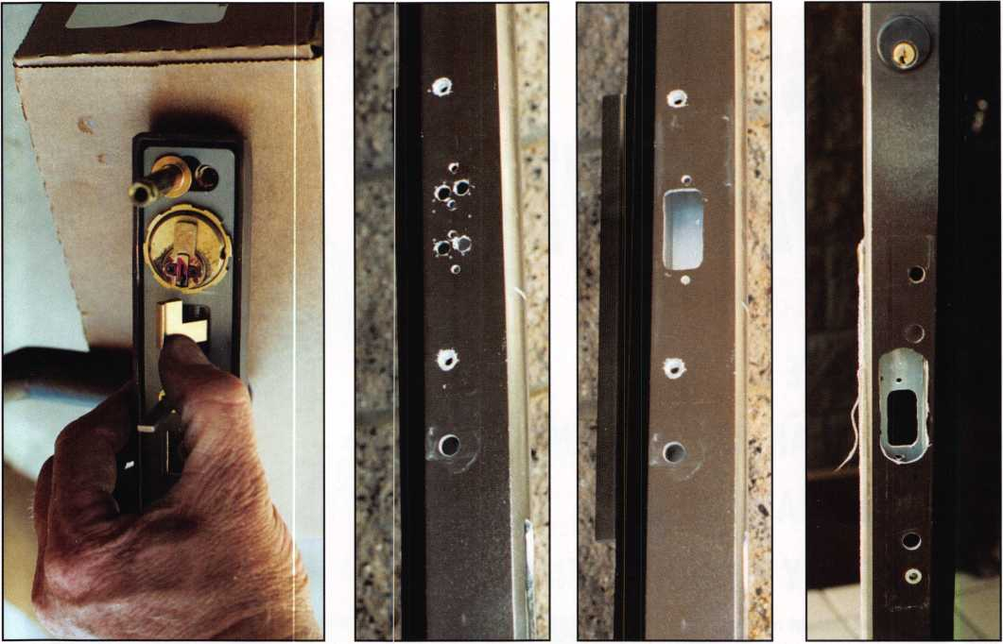

Photo 9 Photo 10 Photo 11 Photo 12

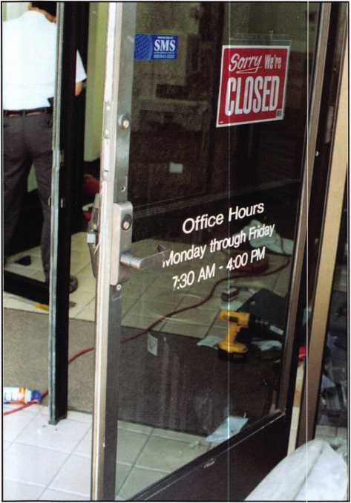

Photo 12

locking lever pushed to the unlocked side. You can also turn the plug 360 degrees to move the cam to the locked side of locking lever.

We started the cutout on the inside of the door with a series of small holes outlined on the door (seen in photo 10). The cutout, done with a router can be seen in photo 11. The outside cutout for the trim was completed in a similar fashion (seen in photo 12). The finished install in is pictured in photo 13.

This install took a full day for two technicians to com­plete. The first pair required close to 12 man-hours to install. The second set went faster, (only 4 or 5 hours). Future jobs will be bid at 10 to 12 hours. Although no part of the job was extremely difficult, the total install might be more involved than some might want to tackle. That’s part of the reason we got the job. Know your skill level and always be willing to exceed it slightly. It will make you a better technician.



Keynotes • November 2004

**notice**

SBS5?

well, **your customers** are...

In today’s world, people do everything by computer. Many people would rather use an internet search than the local phone book to find what they are looking for. Ready to take advantage of that? ALOA has the answer.

The Locksmith Search

That’s right. People can find you by using the ALOA website. They can search by City, State, Zip, hours of operation, even by your areas of expertise! And best of all, this service is free to ALOA members.

So what’s the eaten? All you have to do is fill out the form online in order for your business to be searchable. You can find this form by visiting ALOA at

**[www.aloa.org/locksearch](http://www.aloa.org/locksearch)**

So don’t get overlooked. Make sure you get your name on the locksmith search list today!

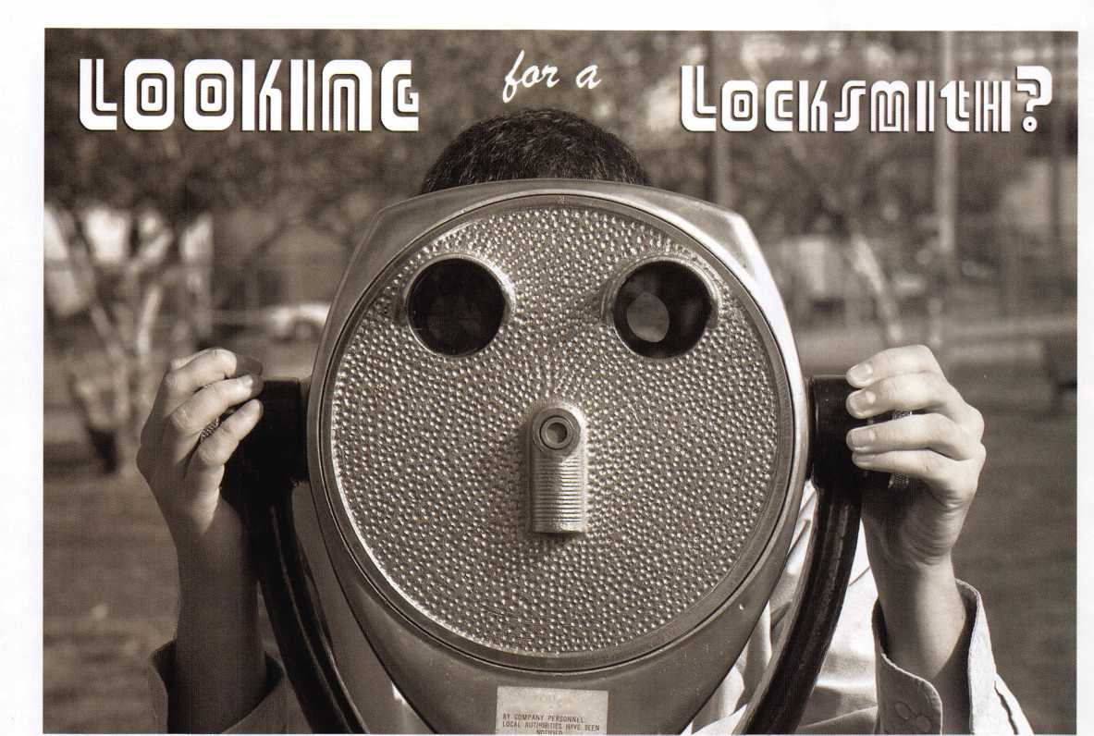

**RING of a KING**

Member Name Sponships

Kwok-kei Leung 219

Henry W. Raymond 92

Yuriko Yanai 82

Mary S. Ohmit CPL 66

Charles C. Robertson CML 65

William Lee CRL 54

Jack Hobin CPL 51

Clifford D. Lipscomb CML, CPS 46

Michael B. Groves 43

C Allan Halverson 40

David M. Troiano 40

Myeong-Rae Cho 38

Jim Williams CRL 37

David M. Lowell CML, CMST 36

Salvatore J. Dulcamaro CML 36

Dana L. Barnum CML 35

Barry K. Leas CRL 35

Danny W. Rudd CPL 33

Larry A. Warnick CML 31

Eugene R. Altobella Sr 31

Jeanne G. Lodge CML 30

Robert D. DeWeese CML 30

Scott L. Henke CPL, CPS 28

Dallas C. Brooks 28

Breck H. Camp CML 27

Lawrence F. Smith Jr, CML 27

John C. Elliott Jr, CML, CPS 27

Marian M. Swann CRL 27

James M. Watt CML, CPS 27

Robert W. Duman Sr, CML 27

William L. Young CML, CPS 27

Anthony J. Ramunno CML, CPS 26

Jeffrey S. Nunberg CML, CMST 26

J Thomas Hood CML 26

Ken Dale 26

Robert H. Stafford CML 25

Philip A. Rovenolt CPL 25

William T. Beranek 25

John L. Shandy CML 24

Elvis D. Hammerschmidt CPL 24

Jerome L. Cohen CML 23

Peter K. Gauthier CPL, CPS 23

Man-Soo Seo RL 23

James J. Cawby CML, CPS 22

James L. Hancock CPL 22

Hans Mejlshede CML 21

John S. Dorsey CML, CPS 20

Thomas G. Vandersteen CML, CPS . 19

Peter Sarailian CRL 19

Walter W. Lascar RL 18

Keizo Takahashi CRL 18

James E. Fowler Sr, CML 18

David C. Harris CML 18

Ronald E. Heidzig 18

Joe J. Lee CRL 18

Takashi Kuwana CRL 18

Eugene R. Altobella Jr 18

Ernest W. Wright 17

Peter R. Hall 17

William P. Grant CRL 17

James E. Gruber CPL 17

Evelyn V. Wersonick CML, CPS 16

Joseph P. Ferrero CML 16

Gary F. Teams CPL 16

Kenneth E. Kim CRL, CPS 16

William J. McElheney CML 16

John W. Soderland CML, CMST 16

Michael E. Jordan Jr, CML 16

Jon B. Griswold CML 16

Brian J. Reetz 16

John A. Ilk CRL, CPS 16

Russell P. Fuller CRL 16

Robert C. Rodocker CPL 15

John J. Greenan CML, CPS 15

Steve L. Cothron 15

Leonard J. Passarello CPL 14

Bruce J. Tarbet CML, CPS 14

John D. Cannon CML 14

Paul M. Souber 14

James T. Brickler CPL 14

Calvin G. Harris CML 13

Frank D. Hartung CML 13

Rolando Bouza 13

John F. Engel CRL 13

Richard C. Sievers 13

Brooke P. Berry CRL 13

William J. Wickward CML 12

Raymond C. Lusk CML 12

Robert M. Massard CRL, AHC 12

Gregory L. Perry CML, CPS 12

Eric F. Veal 12

Barry L. McMenimon CRI 12

Thomas J. Demont CML, 4HC 11

Basil W. Shannon CPL 11

Ralph O. Warren CML 1 1

Gordon R. Racine CML 1 1

Kevin R. Wilson CML, CPS 11

Timothy K. Chow 1 1

Dale L. Knowles CPL 11

Timothy J. Moore CRL 11

Andrew A. Edmunds CML, CPS 11

Daniel S. Enriquez CRL 11

Gene Eldridge CPL 10

Ronald P. Riggins CML 10

Charles E. Haas CML 10

Robert E. Mock 10

Lester S. Brodsky 10

Larry L. Votaw CML 10

Thomas R. Smith CPL 10

Todd K. Ladwig CML, CF'S 10

William! Straub CML 10

Randy L. Hutchison CRL 10

Richard T. Johnson CPL 10

Vincent L. Formon CML, CPS 10

Carroll T. Croson Jr 10

Marian E. Sagar 10

Andrew S. Dennison CPL, CPS 10

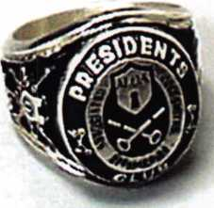

How can I join the President's Club?

You can earn a membership in this prestigious club by recruiting  
just 10 new members for ALOA.

*Any ALOA member may participate.

What do I get?

When you recruit 10 members, you receive a  
handsome blue blazer with a President's Club crest.  
For each additional five members you recruit, you  
receive a lapel pin with gold-filled numbers, indicating,  
your recruiting successes.

You also get the satisifaction of knowing that you are  
helping your association, helping your industry grow,  
and you are helping fellow locksmiths achieve success.

How do I get started?

Mail the form below to the ALOA office for a supply of  
applications (800) 532-ALOA or FAX (214) 827-1810.  
One President's Club credit is awarded for each new  
applicant. Credit is awarded only after the membership  
application is pproved. However, the credit will apply  
for the period in which the application is received.  
Failure to identify yourself as the sponsor on the applica-  
tion form at the time it is submitted to ALOA for process-  
ing will forfeit any credit.

0*77.

|  |  |  |
| --- | --- | --- |
| Yes! 1 want  Please rush me a | | to join the ALOA President's Club.  pplications so 1 can start earning credit toward membership in the club! |
| Name |  |  |
| Company |  |  |
| Address |  |  |
| City Stai | te Zi| | > |

Mail this form to ALOA • 3003 Live Oak • Dallas, Texas 75204-6186

wnat are you

waiting for?

fill it up at the new ALOA store!

NEW AND IMPROVED:

Inventory system: always know if your product is available

Order Tracking: Your tracking number is sent to you via e-mail when your order is shipped.

Order History: See your com­plete order history online

Choose your own shipping method

[www.aloa.org/store](http://www.aloa.org/store)

Try it today!

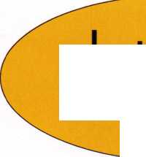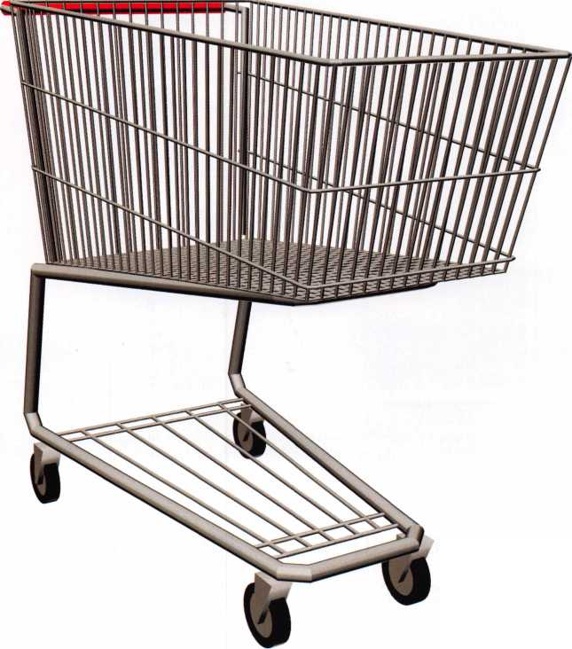

What’s in Your Pickset Pt:. 2

Turners and Spinners

By: Eric Costley, CRL

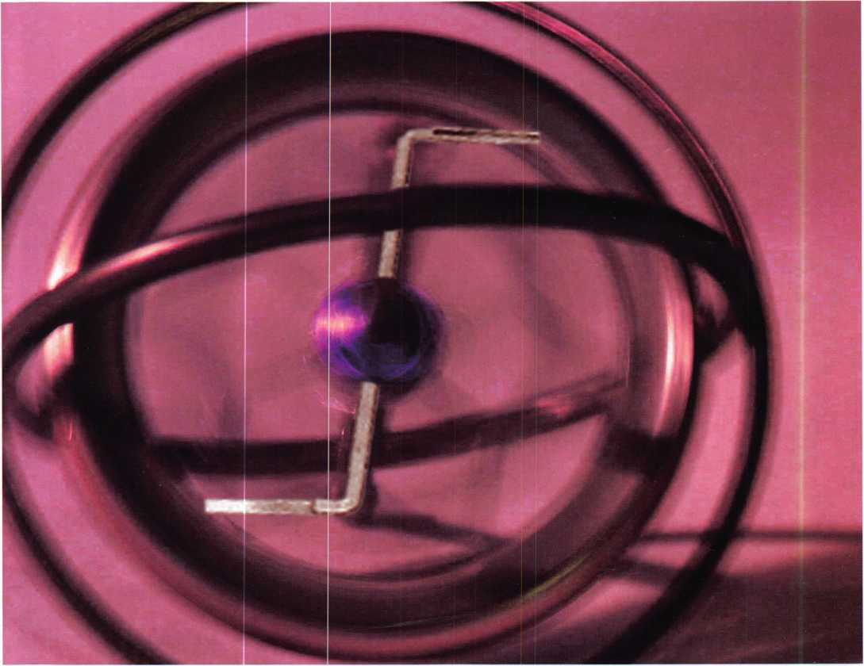

The variety of products available and the fact that each locksmith has specific preferences shows us that the tiny tension wrench is indeed worthy of some further investigation.

Keynotes • November 2004

**No, I’m not** referring to Ike and Tina, or the guys that released the song “Mighty Love” in the seventies, **Y**m talking tools. In the previous article, we discussed a wide array of manufacturers’ products, focusing prima­rily on the picks themselves. Just as the choice of picks is a matter of personal preference, so is the selection of a tension tool. Whereas some may prefer a more flexi­ble tension wrench, others tend to lean toward a more rigid style. In addition, there are a wide array of unusual and specialty tension tools currently on the market that might make your picking experience quicker and easier.

Virtually every set of picks on the market comes equipped with at least a couple of tension wrenches, and most of these are the staples of the industry. HPC, Rytan, Pro-lock, and a myriad of others have supplied us all with our basic tools. Why do we choose these first? Because they are what we are most familiar with. Even so, there are other alternatives.

One might scoff at my extended elaborations over what is essentially no more than a bent piece of metal. However, the variety of products available and the fact that each locksmith has specific preferences shows us that the tiny tension wrench is indeed worthy of some further investigation. In addition, manufacturers vie for our attention and our hard earned dollars by introducing new or elaborate tools; most of these come with the promise of making our picking experience quicker and more successful.

Keynotes • November 2004

**23**

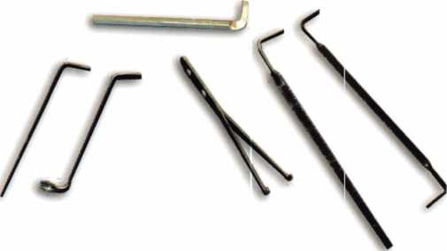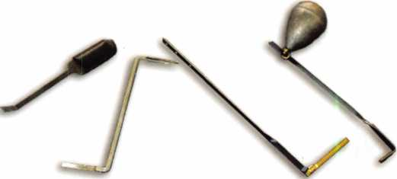

A variety of standard tension wrenches, and  
one "hand made" tool, (top,) manufactured from a spare  
alien wrench.

Left to right: HPC's gateway tool, and  
unknown origin "full plug" tension tool, (note the  
twisted appearance due to poor quality metal,)  
Pickmaster's SC-1 wrench and their weighted tool.

Early on in my career, and under the exceptional tute­lage of my brother Brian, I was introduced to the idea of manufacturing my own tension wrenches from extra alien wrenches, which were carefully ground down to fit our own personal taste. (This early expe­rience probably influenced my preference for a rigid, rather than a flexible tension.) Creating your own tension tools allows you to tailor the length, thick­ness, and angle. I carry a small hand-made tension wrench in my pick set to this day which is designed specifically for small keyways, such as file cabinet locks and padlocks.

Pickmasters manufactures a weighted tension wrench, which has holes in the handle where a variety of lead weights can be attached. Although I normally prefer the “feel” of the tension, and vary it according to the particular lock that I am attempting to pick, I like the idea of having one hand free to wield a flashlight or umbrella. The weighted tension wrench is primarily

designed for use with Pickmaster’s “fiber pick”, but that’s a subject for later discussion.

Peterson has come up with a nifty idea: a serrated tension wrench. If you’re like myself, there’s more than once that your pick has knocked the tension wrench onto the ground, or through the slats in the porch floor... or into the deep snow where it is lost and gone forever. The serrations on the business end of the tension wrench help to hold it securely in the plug, and one of these fine tools has found its way into my “go to” pickset, where it is one of my pri­mary tension wrenches. Although a set of three wrenches costs nearly $30, I highly recommend these!

I also admire Peterson for designing a tool specifically for creating your own tension wrenches. Since acquiring my Peterson picks, I have used this a few times, and I like the idea of tailoring a tension wrench to any given need, on the scene.



Keynotes • November 2004

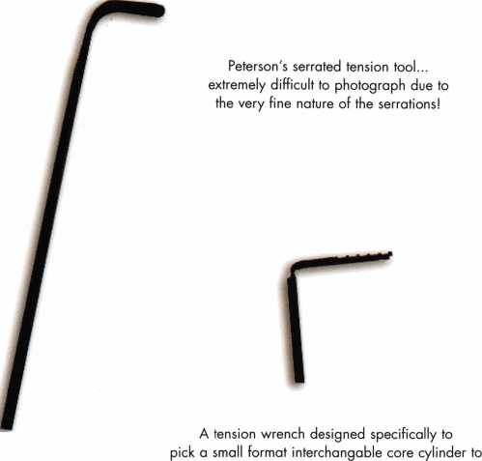

the control key shear line.

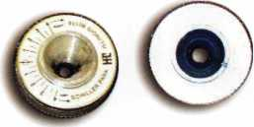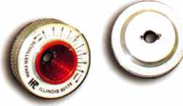

HPC's spring tension tools. Some are  
inverted to show the "pins" which are designed to fit  
into the keyway.

Over the years, there have been some inter­esting gadgets that have found their way onto the market. HPC makes a fine little “gate­way tool”, a device designed to hold the shutter cover of automotive locks open while you pick the lock. Although it is designed primarily just to keep the shutter cover out of the way, it also doubles as an effective ten­sion wrench. It is also invaluable as a means for inspecting auto locks for bent wafers, as it secures the shutter cover and allows you two hands, one for a lighted scope, and another for a pick, probe, or extractor.

Tension wrenches designed specifically for small format interchangeable core cylinders also exist, and the designated use is even more specific than that: they are designed to pick the core to the control key shear line so that the core can be removed from the cylin-

**New!** Keedex

Stainless Steel  
Armored Door Loops

ALL

lit -ifk STAINLESS STEEL

■«£■ DESIGN

HI FLEXIBLE STAINLESS STEEL CONDUIT

II STAINLESS STEEL END PIECES

Jfjf STAINLESS STEEL  
MU MOUNTING SCREWS

COSTS NO MORE  
THAN MOST DOOR  
LOOPS THAT HAVE  
PLASTIC END PIECES

AVAILABLE FROM YOUR KEEDEX DISTRIBUTOR

Call or write today

for yourfree catalog!

Keedex, Inc.

12931 Shackelford Lane

Garden Grove, CA 92841  
714-636-5657 • Fax: 714-636-5680  
e-mail: [info@keedex.com](mailto:info@keedex.com)

[www.keedex.com](http://www.keedex.com)

MADE IN U.S.A.

Keynotes • November 2004

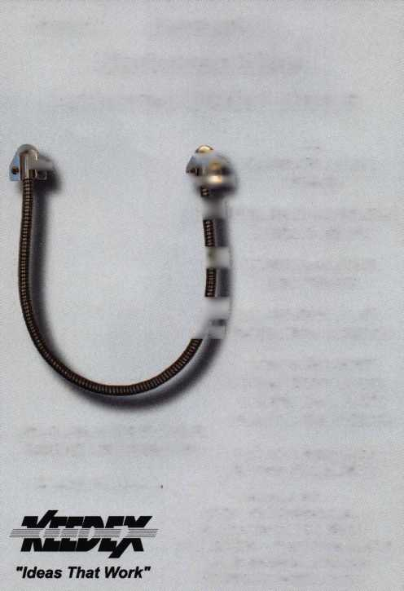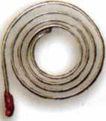

der. I have one in my array of tools,  
but have seldom, (if ever,)

used it.

Additionally, I have a  
unique tension wrench in

my vast array of tools: a full

plug length tension tool that, despite

These are "clockspring" style

spring-loaded tension tools. Note that the fine design, is made of a lesser  
one is clockwise, and the t r i i '-r-i i

other counterclockwise, grade of metal than most. The theory

is that by applying equal tension  
throughout all the pin chambers, pick-  
ing a cylinder becomes easier and  
quicker.One end is designed specifically  
for Kwikset locks, and the other is sim-  
ply a generic straight tension tool. The

twisted appearance in the photo shows that although this is a tool designed with thought, the end product leaves a bit to be desired. Similarly,

Pickmasters markets tension wrenches which actually incorporate keyblank profiles. The keyblank is cut down to the lowest depth of that particular manufacturer, and this ensures that any pin at the deepest cut is already “picked”, or resting at the shear line. (With the use of their fiber picks, this is a great advantage.) Oh, and by the way... those who have studied the engi­neering end of picking locks say that the tension wrench should be placed at the top of the keyway, closer to the

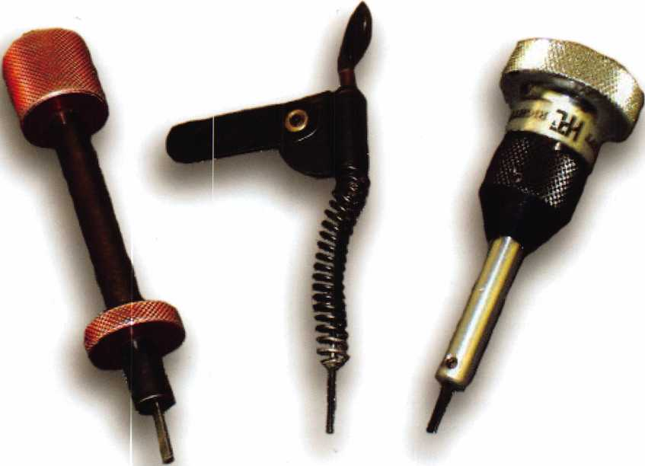

Three of the most common plug spinners on the market. Left to right, the Rytan, the A-l, and the HPC.

**26**

Keynotes • November 2004

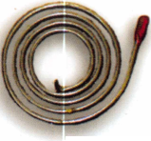

shear line and out of the way of your pick. I tend to drop mine to the bottom of the keyway, and it hasn’t seemed to hinder me... at least much... to this point...

A variety of spring loaded tension wrenches have come and gone over the years, and some of the ones that I’ve photographed here are of unknown origin. The idea behind a spring loaded tension wrench is that different amounts of tension are required for dif­ferent manufacturer’s locks. If you can determine that a Kwikset requires “X” amount of tension, and that Schlage requires “Y” amount of tension, you could theoretically simply turn a spring loaded ten­sion wrench to a given torque for that particular lock, and achieve successful picking more regularly and effi­ciently. Although I personally think each lock

requires its own individual manipulation, I can see that any given manufacturer’s locks would conform somewhat to certain tolerances, which might make these tools useful. One of the drawbacks to spring loaded tension tools is that some of them use two “pins” which are inserted in the keyway, and not all keyways are conducive to this method: either the pins don’t fit in the keyway, or they interfere with the picking process. The aged “clockspring” tension tool of unknown origin in the photo seems to me the sim­plest and most effective design of this type of tool.

Now that we’ve graduated to spring loaded tools, it’s time to start looking at plug spinners. If you’ve been in the business for a while, you probably know that a Kwikset knob always picks counter-clockwise, and a

**THE HINGE DOCTOR**

**by GKL Products**

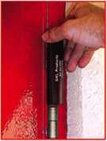

**HA1 For  
Standard**

**Commercial**

**4-1/2” x 4-1/2"**

**Butt Hinges**

**HA2**

***"The HULK'***

**For Residential**

**COMING IN  
SEPTEMBER**

**HA3**

**For Ball- Bearing**

**Commercial Hinges**

The Hinge Doctor is a great way to repair those sagging metal  
doors. Slip the tool over the hinge and open the door an inch

or two past the point where the tool binds against the

hinge, remove the tool and check the door,

which should now be working properly.

**If you're a locksmith these tools  
will turn a profit the 1st time you  
use them!**Uses - **schools, hospitals,**

**commercial buildings, storefronts**

**with butt hinges, office doors, new**

**construction, door alignment, sagging**

**doors, jail cells, anywhere there are  
commercial grade hinges.**

**HA4**

**For Prison**

**& Institutional**

**Hinges &**

**Spring Hinges**

Over

**10,000**

Satisfied

Customers

US Patent **#6450003**

[www.hingedoctor.com](http://www.hingedoctor.com)

**800-924-5397**

Keynotes • November 2004

**27**

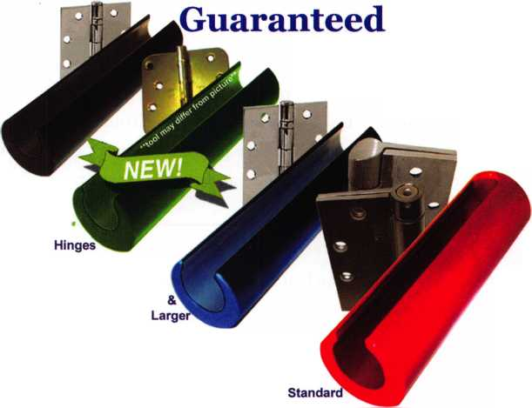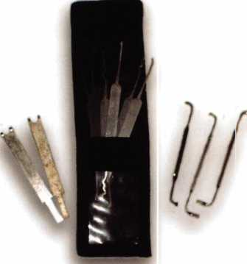

The Lab pickset that came free from ALOA a year or two back. Notice the  
nice thin tension wrenches which are great for tiny keyways. Notice  
also that some of mine are already broken!

Schlage invariably picks clockwise... but the cylinder may not always cooperate. Plug spinners allow us to capitalize on our own mistakes, and double our chances of successfully picking a lock. The theory behind a plug spinner is that it rotates the plug faster than the spring loaded top pins can drop back into the pin chambers of the lock. No matter which direc­tion you pick the lock, you have achieved your goal.

The primary plug spinner that I see in most every tool kit is the A-l. It is simple in design, durable, and compact enough to fit in most pick sets. This is the “gold standard”, as far as I am concerned. I kept one of these handy for years, until the spring finally broke.

When it did, I replaced it with the Rytan “push but­ton” style plug spinner that I have carried ever since. Although a bit bulkier than the A-l, the enclosed spring doesn’t tend to catch on other stuff in the tool kit, and I like the push button rather than the flip lever that tends to give my fingers a nasty snap.

HPC also makes a similar tool, the “flip-it”, which is shorter in length, but larger in girth. As always with such things, personal preference seems to dictate what winds up in any given locksmith’s tool box.

Before I conclude this segment of “What’s in your pickset?”, I have to tell you a story about one of my former employers, Perry Apking, to whom I am indebted for much of my education early in my career. Perry had an interesting method for picking a Weiser knoblock... without a tension wrench! He would use a rake pick, inserted fully into the lock.

He would then twist the pick in a clockwise motion, applying tension to the plug, and yank the pick out rapidly. Usually, within 3 or 4 tries, the lock would pick. I’ve attempted this technique with limited suc­cess, but I must admit that watching Perry do this was quite a sight.

Next month we’ll be exploring specialty picks, and because of the vast array of tools and applications we will be packed with more information than you might be able to digest in one sitting! Want a sneak pre­view? Rocker picks, fiber picks, tubular picks, com­puter picks... and the list goes on.

Technical Editor's Note: The term “tension tool" has become a locksmith-industry standard. Purists may argue that these are, in fact, “torque tools” because they actually exert torque on the plug, which then binds the thumb tumblers.

Keynotes • November 2004

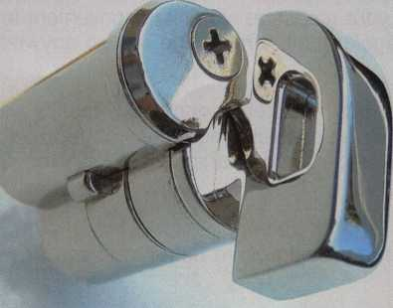

..Herculite doors  
without pulling them  
down.

..cabinet lock to  
convenient thumb latch  
operation.

..double cylinder lock  
to single cylinder.

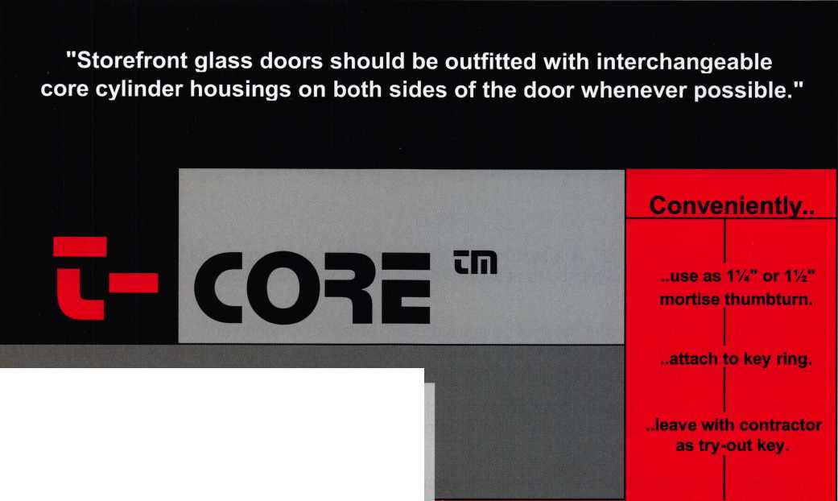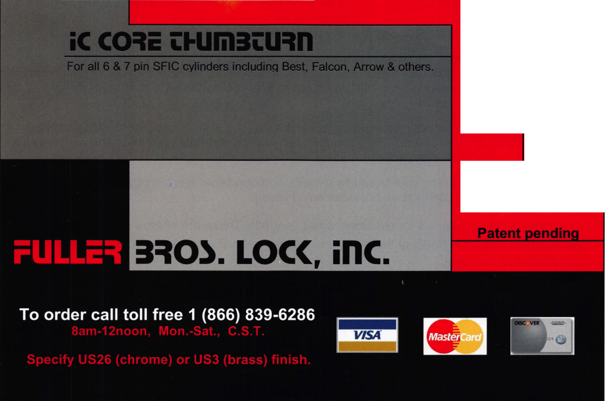

: Edit Insert Format Tools Actions Help

|  |  |  |  |  |  |  |  |  |  |  |
| --- | --- | --- | --- | --- | --- | --- | --- | --- | --- | --- |
| Send Save | Attach | Options |  | Normal | ▼ | Arial | 10 - | A | B / U | se: :§=§: ~3§ izz |n |
|  | | |  | |  | | | | | |

**o... |** | Keynotes Readers

**rom... [** | Claire L. Cohen, CML

bject: j Before you push the send button

E-mail, short for electronic mail, is a system in which a computer user can exchange messages with other computer users with a communications network. To use email, you must have access to a computer that is linked to the outside world.

It was only a short time ago that most of us started using email as an easy and convenient form of com­munication. The more we used it, the more we liked it. We could see the benefits as a personal form of communication, as well as an efficient and timely means of business communication.

One advantage for the E-mail used is that you send your message when it is convenient for you. It's avail­able "24/7". E-mail is a thousand times faster than regular mail. A message can go anywhere in the world in seconds!

Your recipient can respond at his or her convenience - no more telephone tag. E-mail is also cheaper by far. It lets you exchange vast amounts of information in expensively, regardless of geographical location. E-mail can be sent to many people at the same time, and you can participate in ongoing discussion on many subjects at the same time.

E-mail is what the experts call a nearly "frictionless" form of communication, which means it is easy to do. You don't have to go to a post office or even find a stamp. Just push a button and you can blanket the world with your thoughts.

Reluctance to use E-mail has faded away, and we have become more proficient and sophisticated with its use. We find that people of all ages and businesses of all types are using e-mail more often. Some of our earlier bad habits have persisted, and some new problems have emerged.

In the past, the most prevalent problem was information overload, which was aggravated by the wide­spread adoption of e-mail. Now that the situation has become well-established, an overwhelming number of people and businesses are now on e-mail. We have to deal with business e-mail, personal e-mail, and assorted varieties of "junk" e-mail.

As security professionals, it is our responsibility to send a positive e-mail message to our customers (or potential customers). Don't push that "Send" button until you are sure that your message represents a first-rate image for your business.

Take an active role in controlling your business e-mail's outbound flow. It is particularly important to edu­cate every member of your staff to use business email wisely.

Here are some simple guidelines for electronic email etiquette. These are offered to highlight some impor­tant issues which affect the clarity of the electronic mail we send. Electronic mail is about communication, so clarity should be our goal.



Keynotes • November 2004

* Use email only when it is the most efficient chan­nel for your business need.
* Keep an up-to-date address book. You may be writing to someone with an address that is no longer valid.

- Use correct grammar and spelling. Electronic mail is all about communication. Poorly worded and mis­spelled messages are hard to read and potentially confusing. If your words are important enough to write, then they are important enough to write properly.

- When sending business-related email, a personal name on the first line of your text identifies better who the email is intended for.

- When replying to an e-mail, pay

careful attention to where your

reply is going. Did you reply

to one person of "reply to

all"? It can be embar-

rassing for your busi  
ness if the message

ends up on the  
wrong mailing list.

Ensure that your thoughts will be sent to the correct person, and to that person only!

- Make sure you  
have a subject  
line in your mes-  
sage. Almost all

mailers present you  
with the subject line  
when you browse your

mailbox. It is often the only

clue the recipient has about the

content when filing emails or search-

ing for messages. Make the subject line mean-  
ingful. For example, "Price Quote for Heavy-Duty  
Padlocks." With the overload of email that is  
received, a clear subject line is imperative.

- Proofread your e-mail carefully. E-mail often con­tains typos and misspellings because it is so easy to produce and send. Spell-check programs which are built into many software packages can help, but should not be the sole source of proofreading.

receives many  
messages each  
day. Including the

relevant section  
from the original

message helps the  
recipient to place your

reply in context. Include only

the minimum you need from the

original message.

- A "signature" is a small block of text appended to the end of a message, which usually contains contact information. Always use a signature block, making sure it identifies who you are, your business name, e-mail address and includes alternative means of contact (phone, fax, etc.).

- In general, keep to the subject as much as possi­ble. If you need to branch off onto a totally new and different topic, then it is often better to send a new

- If you are responding to a message, make sure  
you clearly refer to the original message's contents.  
Always include a descriptive subject line in your

message such as: "Re: Proposal for

Security System." Include enough

of the original message to

provide a context.

Remember that elec-

tronic mail is not as  
immediate as a

telephone conver-  
sation, and the

recipient may  
not recall the  
contents of the  
original mes-  
sage, especially  
if he or she

message.

Keynotes • November 2004

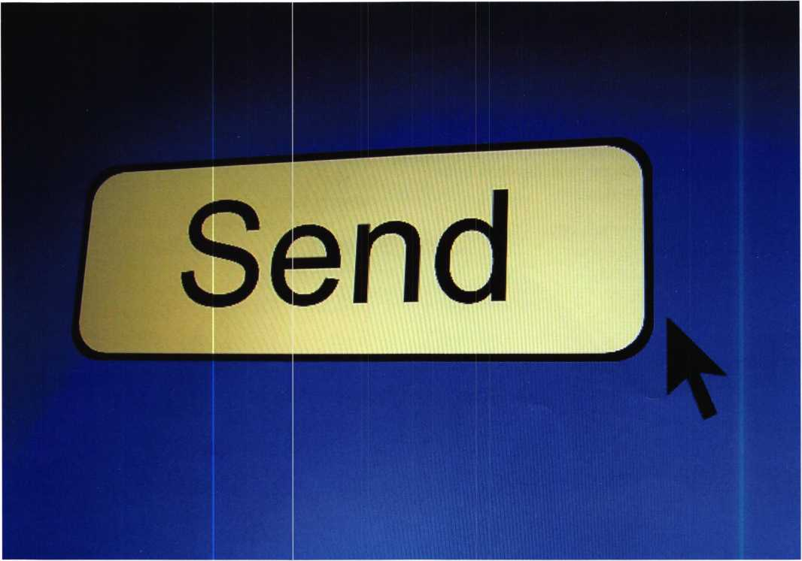

- If you are asking for something, don't forget to say, "please". Similarly, if someone does something for you, it never hurts to say, "thank you."

* Don't send email when you are furious or exhausted. Don't commit anything to writing that you may be sorry for later.
* Write clearly and carefully. Your words can come back to haunt you. Read carefully what you receive, to make sure that you are not misunderstanding the message. Read carefully what you send, to make sure that your message will not be misunderstood.
* Check and double-check any prices, part numbers, etc., as you would in any written document.

Beware...e-mail is dangerous! You can send a message much more quickly (almost too quickly). You may not have thought it out. And once the message is sent, it is too late to change it!

Never substitute e-mail for a necessary face-to-face meeting. When you are trying to persuade someone to do something, or someone wants to persuade you, there is not substitute for a face-to-face meeting.

Above all else, remember that electronic mail is about communication with other people. When you compose and email message, read it carefully before sending it. Ask yourself what your reaction would be if you received it. Any time spent on making ari e-mail clearer is time well spent.

E-mail is an extremely efficient and powerful form of communication. With the new power of electronic mail comes the need for responsibility in using that power. With this incredible power of this business tool, we can all benefit from it. But be careful...think twice before you push that "Send" button.



Think you’ve seen everything ALOA can do on the web?

Think again. We’re about to unleash what you’ve been waiting for.



something



is

j list

down

the

Road

|  |  |
| --- | --- |
| _ X. „ ... ' | Introducing the all new |
| I ■; | [www.aloa.org](http://www.aloa.org) |
| IP:  Si: | Coming this December to a computer near you |

Pu* Pi

t<y

90*J*l

Keynotes magazine is now recruiting new writers for upcoming issues and  
we need your technical expertise! Contribute to ALOA and share your  
knowledge. Just think, you could have your name in lights! (Ok, not actu-  
ally lights. But print is almost as glamorous.) We will even compensate you  
for your efforts. Here are just a few benefits of being a Keynotes author:

* Cash for stories ($250-400)
* A special-edition author kit
* Recognition at ALOA conventions
* Access to Keynotes message boards (available Feb 05)

So what are you waiting for? Contact us today about  
joining the elite team of Keynotes authors!

[editor@aloa.org](mailto:editor@aloa.org)

Upcoming Topics:

Specialty Locks  
Access Control  
Safes

High Security  
Crime Prevention  
Tools

Automotive  
Electronic Locks  
Institutional Locksmithing  
Business

Authors' Payment: Payment for eligible submissions to Keynotes will be based on the following criteria: topic, time spent and past contributions. Authors who regularly submit to Keynotes® ore generally paid a higher rate. The latter is especially true of authors who write to fit specific editorial needs and submit said copy by Keynotes® deadlines. As a general guideline: Average payment for a 750 word, business or 'light' technical article would be S200. Payment for a 1500 word article involving significantly higher time and research efforts would be $400. Payment will not be offered for articles submitted by ALOA employees or members of the ALOA Board of Directors (unless material is of a technical nature), nor for articles submitted by a company that promote that company's products or services. ALOA reserves the right not to pay for articles submitted by an individual(s) that promote a particular company's products or services. Disclaimer: The Associated Locksmiths of America, Inc., (ALOA), reserves the right to refuse any article for any reason. Additionally, ALOA reserves the right to edit, amend or modify any article submitted for publication in order to preserve technical accuracy, clarity, fairness or grammatical correctness. ALOA will make the best efforts to notify the author of any changes. The extent of ALOA's liability for any article or information contained therein will be a notice of cor­rection or retraction in the next possible issue. Keynotes® (ISSN 0277 0792) is published monthly except for the combined July/August issue by The Associated Locksmiths of America, Inc., 3003 Live Oak St., Dallas, TX 75204-6186. Telephone: (214) 827-1701; FAX (214) 827-1810; e-mail [aloa@aloa.org](mailto:aloa@aloa.org). Subscription rates for members-$l 5 per year. Business class postage paid at Dallas, Texas. POSTMASTER: Send address changes to: Keynotes, 3003 Live Oak St., Dallas, TX 75204-6186. © Copyright 2003, All rights reserved. No part of the contents may be reproduced or reprinted in any form without prior written permission of the publisher.

SIMPLEX 900 SERIES — Compatible With Keedex

Weldable Gate Boxes

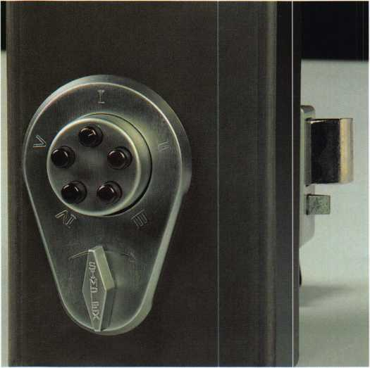

Kaba Access Control is pleased to announce a simple, strong and  
secure Keyless access control solution for commercial and residential  
gates. The Simplex 900 together with a Keedex weldable gate box is  
perfect for drop boxes, storage facilities, swimming pools, garages or  
any area that you want to secure.

The Simplex 900 pushbutton lock’s all-metal, mechanical, weather  
resistant design makes it ideal for any gate location. Installs easily  
using the Keedex weldable gate box, K-BXSIM-200, available in  
both 14-gauge steel and aluminum. Box is prefabricated with all  
drills and is ready for lock installation.

For additional information on the Simplex 900, call 800-849-8324  
or visit [www.kaba-ilco.com](http://www.kaba-ilco.com). For information on the Keedex weldable  
gate box, call (714) 636-5657 or visit [www.keedex.com](http://www.keedex.com).

With over 40 years of proven performance, you can count on  
Simplex.

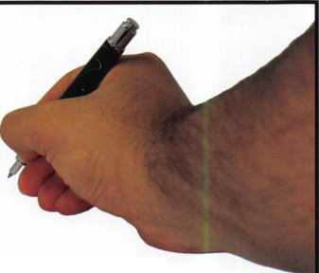

fffifv ,

,

II

**5/8m** Deadlocking Latch

WIN

**SIMPLEX SHOPPING SPREE**

Send us your 900 Series Installation success story and you’ll be entered for a chance to win a FREE $500 Simplex Shopping Spree. Each entrant will also receive a FREE Simplex ball cap. The best story will be selected to appear on the Kaba website with your picture and story. Send your story and photo to Simplex Shopping Spree, 2941 Indiana Ave., Winston-Salem, NC 27105. (One story per dealer)

~~ '

twiP/f !-!

jjjli 1

ffSi I

i III if

§ ;?Hn

900 Series

Kaba Access Control continues to offer you  
a simple, strong and secure pushbutton  
lock alternative, even in today’s high tech  
world. With over 40 years of proven per-

formance, you can count on  
Simplex to handle all of your  
access control needs.

Keyless convenience

no keys or cards

Easy to install

no wiring or computers

Easy to maintain

no batteries to replace

Easy to manage

one code, can be changed  
in seconds

The Simplex 900 Series offers an  
economical solution for both commercial  
and residential applications. An all-metal,  
weather resistant design makes it perfect  
for any location. The lock can be mounted  
above an existing lockset or used alone. Its  
rim mounted latch and field reversible  
design make installation quick and simple.

Available in a variety of options and models:

Deadbolt - 1" throw, manual relock

Deadlocking Latch - %" throw, automatic  
relock with latch holdback

Variable Door Thickness - available for  
doors 1%" to 21/2"

Optional Key Override - key access for  
emergency and service personnel

J

**KARA**

**1-800-849-8324**

**[www.kaba-ilco.com](http://www.kaba-ilco.com)**

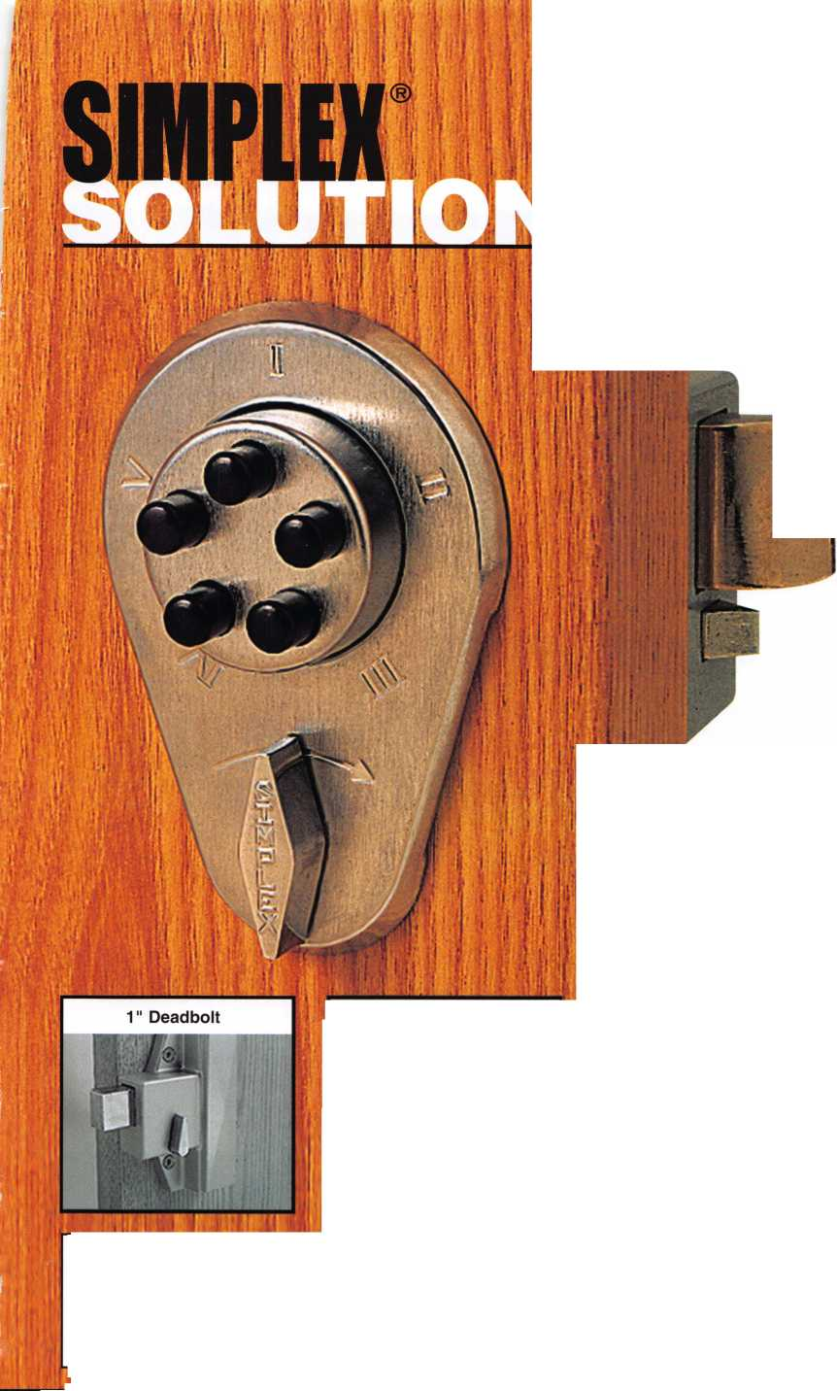

Classifieds



EMPLOYMENT

LOCKSMITH WANTED

Busy shop in Woburn, MA is looking for experi­enced locksmiths to join our team. If you're a self-motivated hard worker willing to work rea­sonable hours and be compensated for your abilities, this is for you. We have a large client base for commercial, residential, safes, door and glass storefronts and automotive customers including 2 AAA contracts. Please call John for more information at 781-933-9999 or send resume to: Locks & Keys Inc., P.O. Box 222 Woburn, MA 01801 (all inquiries kept strictly confidential)

IN-STOCK...MORE SAFES

***FREE Freight Program***

***(30 States)***

AMSBC FireKing

Gaidai **hayman**

MEIUNK y/CTO/i

**TURD to**

**WHOLESALE SERVICE**

800-848-9790

HELP WANTED

Argens Incorporated, a full service security company, is expanding. We are looking to add experienced, personable people in all aspects of our company. Inside and outside positions are available. If you have locksmithing or electronic security experience and want to live in the Pacific Northwest, please email [stevet@argens.com](mailto:stevet@argens.com). All positions are full time with a good wage, health insurance, retirement plar, holidays and generous vacation pay.

A&B Security Group is a well established, fast growing locksmith security company in Las Vegas. We are looking for the right individuals to grow with us and become part of the future. If you are looking for a future, not just a job, then we want you!

* Medical Benefits
* 401 K Program with Matching Dollars
* Paid Vacation
* Good Work Environment
* Advancement
* Established Company

For a confidential interview, call Gary of Phil - 702-362-0222

EXPERIENCED LOCKSMITHS

Nationwide company needs F/T, P/T independ­ent contractors throughout the U.S.: Nashville/Knoxville, Mobile, Atlanta, New Orleans, Dallas/Houston/San Antonio, Little Rock, Conn., Mass., Rl, NY and Oklahoma. $1500 - $2500 wk. Full Service Ability or "Ni e-Owls" a PLUS ie: auto/residn'I/comm-lock- out/rekey, etc. MUST have your own vehicle/tools. Please call Paul (617) 921-2758.

The **University of**

Arizona.

**Tucson Arizona**

ASSISTANT MANAGER FOR ACCESS CONTROL - RESIDENCE LIFE

Responsible for the development, planning & coordination of activities related to all aspects of access control for Residence Life. Will establish & maintain a master key system for all Residence Halls & will supervise Residence Life key desk personnel & operations in direct support of Lock Shop Operations, Card Access & Emergency on call. Successful candidate must pass criminal background evaluation. Salary: $42,000 - $47,000 annually + outstanding UA benefits.

For full details & to apply, complete the online application for job# 31790 at [www.hr.ari- zona.edu](http://www.hr.ari-zona.edu). Be prepared to attach resume & letter of interest. Review of materials will begin 1 1 /1 /04 & continue until position is filled. The University of Arizona is an EEO/AA Employer- M/W/D/V.

LOCKSMITH - RESIDENCE LIFE

Repairs, installs and services locks and related hardware to include electronic access control systems for Residence Life buildings. Salary: $28,144 annually + outstanding UA benefits.

For full details & to apply, complete the online application for job# 31811 at [www.hr.ari- zona.edu](http://www.hr.ari-zona.edu). Be prepared to attach resume.

Review of materials will begin 1 1/1/04 & con­tinue until position is filled. The University of Arizona is an EEO/AA Employer-M/W/D/V.

2005

EAST COAST REGIONAL

LOCK & SECURITY SHOW

(CLASSES, TRADE SHOW, AND BANQUET)

March 3rd thru March 6th Crowne Plaza Meadowlands Hotel

For More Information:

PO Box 2441

Morristown, NJ 07962-2441 Fax 973-538-1588 Or visit our web site at [www.mlanj.org](http://www.mlanj.org)

WANTED TO BUY/SELL

WHOLESALE SAFE DEPOSIT LOCKS

Diebold, Herring Hall Marvin, llco, LeFebure, Mosler, Precision, S&G, Security Corp, Yale. Now available Safe Deposit Boxes Sections, Doors, Hinges and Bond Tins. Vault Doors, Safes, Night Depositories, Vault Lockers and One Inch Plate Steel are also stocked items. Call WBI (954)484-2404 or [Sales@WBI.US](mailto:Sales@WBI.US).

EQUIPMENT FOR SALE

Scotsman #747XU Tubular Key Machine (cuts to codes or dupli­cates) with manual, used very few times - $500.00 HPC general code book 1A - $50.00 - A set Reed code books 1-14 with index $500 for set - Reed code book #5 Padlocks $50.00 - Baxter code books 1,5, 11, 19, 20, 22, 23, 24, 27, 28, 29, 30, 31, 34, 35, 36, 37, 38 updated through 2003 $500.00 for set - Kent-moore Vats key interpreter $100.00 - A-l Auto key punch set with case (PAKSSB) $500.00 - ASP Auto Cap Assortment #A0-002 (with the original face caps) $100.00 - An inventory of Dead Bolts, lock sets etc. Listing will be sent if you will send a SASE (business size). All items are F.O.B. Narvon, PA. Byron A. Rohrbach RL, 2543 School House Lane, Narvon, PA, 17555-9004. Phone (717) 445-1240.

FOR SALE

Al-Pak-A-Punch III never used in carrying case, with 7 auto kits (Ford FA/FB/Ford 10 Cut/GM 6 Cut/Chrysler F/M/Y 60000/Chrysler EP/ES/Chrysler S/L all never used! $400.00 for all. Both in carrying cases. 860-423-5604.

Classified Advertising Policy

Classified advertising space is provided free of charge to ALOA members and for a fee of $2.00 per word, $40.00 minimum for non members. Classified ads may be used to advertise used merchandise and overstocked items for sale, "wanted to buy" items, business opportunities, employment opportunities/positions wanted and the like. Members or non members wishing to advertise services or new merchandise for sale may purchase a "Commercial Classified Ad" for a fee of $4.00 per word with a mini­mum of $100.00. Each ad will run for two issues. For blind boxes there is a $10.00 charge for members and non members. All ads must be submitted in writing to the Advertising Sales Department via fax at 817-645-7599 or through an email to [adsales@aloa.org](mailto:adsales@aloa.org) by the fifteenth of the month two months prior to issue date. ALOA reserves the right to refuse any classified advertisement that it deems inappropriate according to the stated purpose of the classified advertising section.



**SAFE CORPORATION**

Viking Stainless

Fire & Burglary Protection  
State of the Art Composite Fill

Strong • Functional • Attractive

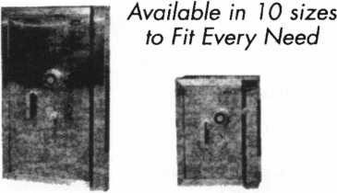

See us at [www.a-bsafecorp.com](http://www.a-bsafecorp.com)

1-800-253-1267

Fax 856-863-1208

CALL FOR YOUR CATALOG TODAY

25+ Function  
Multi-Tool

**—** Lifetime Warranty **—**

R LOCKSMITHS ONLY

> 25 Functions  
» Services Schlage, Baldwin,

Corbin/Russwin, Lori,

Adams Rite, Master  
padlocks, Medeco, Arrow,

Jackson crossbars and

many more!

Call Toll Free...

888-634-LOCK

[www.lockmantools.com](http://www.lockmantools.com)

MasterCard

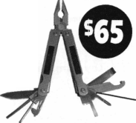

Distributor

**1 st In Hardware, Inc.**

Phone: 866-397-9900 Fax: 866-646-0045 www. 1 stinhardware.com

**ADI Inc.**

Phone: 631-692-1000 Fax: 631-692-3011

**Accredited Lock Supply Co.**

Phone: 800-652-2835 Fax: 201-865-0030 [www.acclock.com](http://www.acclock.com)

**Ace Lock & Security Supply**

Phone: 800-223-5625 Fax: 908-688-2442 [www.acelock.com](http://www.acelock.com)

**Andrews Wholesale Lock Supply**

Phone: 717-272-7422 Fax: 717-274-8659 [www.andrewslock.com](http://www.andrewslock.com)

**Boyle & Chase Inc.**

Phone: 800-325-2530 Fax: 800-205-3500 [www.boyleandchase.com](http://www.boyleandchase.com)

**Chinrose International**

Phone: 503-357-7553 Fax: 503-357-5522 [www.chinrose.com](http://www.chinrose.com)

**Clark Security Products**

Phone: 888-784-1311 Fax: 619-718-7333 [www.clarksecurity.com](http://www.clarksecurity.com)

**Cook's Building Specialties**

Phone: 505-883-5701 Fax: 505-883-5704

**Dire's Lock & Key Company**

Phone: 303-294-0176 Fax: 303-294-0198

**Direct Security Supply, Inc.**

Phone: 800-252-5757 Fax: 800-452-8600

**Discount Key Machines.Com/Busch**

Phone: 800-332-8724 Fax: 407-363-4666

**Doyle Security Products**

Phone: 800-333-6953 Fax: 612-521-0166 [www.doylesecurity.com](http://www.doylesecurity.com)

**Dugmore and Duncan, Inc.**

Phone: 888-384-6673 Fax: 888-329-3846

**E. L. Reinhardt Co., Inc.**

Phone: 800-328-13’ 1 Fax: 651-481-0166 [www.elreinhardt.con](http://www.elreinhardt.con)

**Ewert Wholesale Hardware**

Phone: 800-451-0200 Fax: 708-597-0881

**Fairway Supply, Inc.**

Phone: 214-350-0021 Fax: 214-352-4299 [www.fairwaysupply.com](http://www.fairwaysupply.com)

**Foley-Belsaw Company**

Phone: 800-821-3452 Fax: 816-483-5010 [www.foley-belsaw.com](http://www.foley-belsaw.com)

**Fried Brothers Inc.**

Phone: 800-523-2924 Fax: 215-592-1255 [www.fbisecurity.com](http://www.fbisecurity.com)

**Hans Johnsen Company**

Phone: 214-879-1550 Fax: 214-879-1530

**[www.hjc.com](http://www.hjc.com)**

Phone: 416-462-1921

[www.hardwareagencies.com](http://www.hardwareagencies.com)

**IDN Incorporated**

Phone: 817-421-5470 Fax: 817-421-5468 [www.idn-inc.com](http://www.idn-inc.com)

**Intermountain Lock & Supply**

Phone: 800-453-5386 Fax: 801-485-7205 [www.intermountainlock.com](http://www.intermountainlock.com)

**International Electronics, Inc**

Phone: 800-343-9502 Fax: 617-821-4443

**Jo Van Distributors**

Phone: 416-752-7249 Fax: 416-752-7282 [www.jovanlock.com](http://www.jovanlock.com)

**Lockmasters, Inc.**

Phone: 859-885-6041 Fax: 859-885-7093 [www.lockmasters.com](http://www.lockmasters.com)

**Locks Company**

Phone: 800-288-0801 Fax: 305-949-3619

**Locksmith Ledger International**

Phone: 770-886-0800 Fax: 770-889-7703 [www.lledger.com](http://www.lledger.com)

**M. Zion Company**

Phone: 212-349-8677 Fax: 212-964-0495 [www.mzion.com](http://www.mzion.com)

**McDonald Dash Locksmith Supply**

Phone: 800-238-7541 Fax: 901-366-0005 [www.mcdonalddash.com](http://www.mcdonalddash.com)

**Monaco Lock Co.**

Phone: 800-526-6094 Fax: 800-845-5625 [www.monacolock.com](http://www.monacolock.com)

**Omaha Wholesale Hardware**

Phone: 800-238-4566 Fax: 402-444-1664 [www.omahawh.com](http://www.omahawh.com)

**RA-Lock Company**

Phone: 972-775-6301 Fax: 972-775-6316 [www.ralock.com](http://www.ralock.com)

**Security Distributors Inc**

Phone: 800-333-6953 Fax: 612-524-0166

**Security House**

Phone: 905-669-5300 Fax: 905-660-6313 [www.securityhouselock.com](http://www.securityhouselock.com)

**Security Lock Distributors**

Phone: 800-847-5625

Fax: 800-878-6400

[www.securitylockdistributors.com](http://www.securitylockdistributors.com)

**Shin-An Enterprise Inc.**

Phone: 718-225-5380 Fax: 718-819-0723

**Southern Lock and Supply Co.**

Phone: 727-541-5536 Fax: 727-544-8278 [www.southernlock.com](http://www.southernlock.com)

**Stone & Berg Wholesale**

Phone: 800-225-7405 Fax: 800-535-5625

**The Locksmith Store Inc.**

Phone: 847-364-5111 Fax: 847-364-5125 [www.locksmithstore.com](http://www.locksmithstore.com)

**Timemaster Inc.**

Phone: 859-259-1878 Fax: 859-255-0298 [www.time-master.com](http://www.time-master.com)

**Top Notch Distributors, Inc.**

Phone: 800-233-4210 Fax: 800-854-4146 [www.topnotch.bz](http://www.topnotch.bz)

**Turn 10 Wholesale**

Phone: 800-848-9790 Fax: 800-391-4553

**U.S. Lock Corp.**

Phone: 800-925-5000 Fax: 800-338-5625 [www.uslock.com](http://www.uslock.com)

**Wilson Safe Company**

Phone: 215-492-7100 Fax: 215-492-7104 [www.wilsonsafe.com](http://www.wilsonsafe.com)

Manufacturer

**A & B Safe Corporation**

Phone: 800-253-1267 Fax: 856-863-1208 [www.a-bsafecorp.com](http://www.a-bsafecorp.com)

**ABUS Lock Company**

Phone: 800-352-2287 Fax: 602-516-9934 [www.abus.com](http://www.abus.com)

**Access Security Products Ltd.**

Phone: 905-337-7874 Fax: 905-337-7873 [www.access-safe.com](http://www.access-safe.com)

**Adams Rite Mfg Company**

Phone: 800-872-3267 Fax: 800-232-7329 [www.adamsrite.com](http://www.adamsrite.com)

**Adesco Safe Mfg. Company**

Phone: 800-694-9340 Fax: 562-408-6427 [www.adesco.com](http://www.adesco.com)

**Adrian Steel Company**

Phone: 800-677-2726 Fax: 517-265-5834 [www.adriansteel.com](http://www.adriansteel.com)

**All Five Tool Company, Inc.**

Phone: 860-583-1691 Fax: 860-583-4516 [www.all5tool.com](http://www.all5tool.com)

**American Lock Company**

Phone: 708-534-2000 Fax: 708-534-0531 [www.armericanlock.com](http://www.armericanlock.com)

**American Security Products**

Phone: 909-685-9680X1083 Fax: 909-685-9685 [www.amsecusa.com](http://www.amsecusa.com)

**Best Metaline Inc.**

Phone: 714-441-0098 Fax: 714-441-0977

**38**

Keynotes • November 2004

**associate**

**members**

**Bianchi USA, Inc.**

Phone: 800-891-2118 Fax: 216-803-0202

**Buddy Products**

Phone: 800-886-8688 Fax: 312-733-8356 [www.buddyproducts.com](http://www.buddyproducts.com)

**CCL Security Products**

Phone: 800-733-8588 Fax: 847-537-1800

**COMPX Security Products**

Phone: 864-297-6655 Fax: 864-297-9987 [www.compxnet.com](http://www.compxnet.com)

**D&D Technologies (USA), Inc.**

Phone: 714-677-1300X292 Fax: 714-677-1299 [www.ddtechusa.com](http://www.ddtechusa.com)

**DETEX Corp.**

Phone: 800-729-3839 Fax: 830-620-6711 [www.detex.com](http://www.detex.com)

**DORMA Architectural Hardware**

Phone: 717-336-3881 Fax: 717-336-2106 [www.dorma-usa.com](http://www.dorma-usa.com)

**Data key Electronics**

Phone: 952-746-4066 Fax: 866-289-4212 [www.datakeyelectronics.com](http://www.datakeyelectronics.com)

**Don-Jo Manufacturing, Inc.**

Phone: 978-422-3213 Fax: 978-422-3467 [www.don-jo.com](http://www.don-jo.com)

**Door Controls International**

Phone: 800-742-3634 Fax: 800-742-0410 [www.doorcontrols.com](http://www.doorcontrols.com)

**ESP Lock Products Inc.**

Phone: 800-434-8960 Fax: 978-562-9859

**FireKing Security Products**

Phone: 800-457-2424 Fax: 800-896-6606 [www.fkisecuritygroup.com](http://www.fkisecuritygroup.com)

**Framon Manufacturing Company Inc.**

Phone: 989-354-5623 Fax: 989-354-4238 [www.framon.com](http://www.framon.com)

**HPC, Inc.**

Phone: 847-671-6280 Fax: 847-671-6343 [www.hpcworld.com](http://www.hpcworld.com)

**HY-KO Products Co.**

Phone: 330-467-7446 Fax: 330-467-7442

**Hammerhead Industries, Inc.**

Phone: 805-658-9922 Fax: 805-658-8833 [www.gearkeeper.com](http://www.gearkeeper.com)

**Ingersoll Rand SSA**

Phone: 317-613-8025 Fax: 317-613-8068 [www.schlagelock.com](http://www.schlagelock.com)

**Jet Hardware Mfg., Co.**

Phone: 718-257-9600 Fax: 718-257-0973 [www.jetkeys.com](http://www.jetkeys.com)

**KABA ILCO Corp.**

Phone: 252-446-3321 Fax: 252-446-4702 [www.kaba-ilco.com](http://www.kaba-ilco.com)

**KEY-BAK/West Coast Chain Mfg.**

Phone: 909-923-7800 Fax: 909-923-0024 [www.keybak.com](http://www.keybak.com)

**Keri Systems Inc.**

Phone: 408-451-2520 Fax: 408-441-0309 [www.kerisys.com](http://www.kerisys.com)

**Knaack Manufacturing Co.**

Phone: 800-456-7865 Fax: 815-459-9097 [www.weatherguard.com](http://www.weatherguard.com)

**LAB Security**

Phone: 800-243-8242 Fax: 860-583-7838 [www.labpins.com](http://www.labpins.com)

**La Gard Inc.**

Phone: 310-325-5670 Fax: 310-325-5615 [www.lagard.com](http://www.lagard.com)

**Lock America, Inc. dba L.A.I. Group**

Phone: 714-373-2993 Fax: 714-373-2998 [www.laigroup.com](http://www.laigroup.com)

**Lucky Line Products, Inc.**

Phone: 858-549-6699 Fax: 858-549-3241 [www.luckyline.com](http://www.luckyline.com)

**M.A.G. Security**

Phone: 714-891-5100 Fax: 714-892-6845 [www.magsecurity.com](http://www.magsecurity.com)

**MUL-T-LOCK USA, Inc.**

Phone: 800-562-3511 Fax: 973-778-4007 [www.mul-t-lock.com](http://www.mul-t-lock.com)

**Medeco Security Locks**

Phone: 540-380-5000 Fax: 540-380-5010 [www.medeco.com](http://www.medeco.com)

**ROFU International Corp.**

Phone: 253-922-1828 Fax: 253-922-1728 [www.rofu.com](http://www.rofu.com)

**Rutherford Controls Int'l Co.**

Phone: 757-427-1230 Fax: 757-427-9549 [www.rutherfordcontrols.com](http://www.rutherfordcontrols.com)

**STRATTEC Security Corp.**

Phone: 414-247-3415 Fax: 414-247-3692 [www.strattec.com](http://www.strattec.com)

**Sargent & Greenleaf, Inc.**

Phone: 800-826-7652X201 Fax: 859-885-3063 [www.sargentandgreenleaf.com](http://www.sargentandgreenleaf.com)

**Sargent Manufacturing Co.**

Phone: 800-727-5477 Fax: 888-863-5054 [www.sargentlock.com](http://www.sargentlock.com)

**Schwab Corp.**

Phone: 765-447-9470 Fax: 765-447-8278 [www.schwabcorp.com](http://www.schwabcorp.com)

**Securitron Magnalock Corp.**

Phone: 775-355-5625 Fax: 775-355-5636 [www.securitron.com](http://www.securitron.com)

**Security Door Controls**

Phone: 805-494-0622 Fax: 805-494-8861 [www.sdcsecurity.com](http://www.sdcsecurity.com)

**Security Solutions**

Phone: 405-376-1600 Fax: 405-376-6870 [www.securitysolutions-usa.com](http://www.securitysolutions-usa.com)

**Townsteel, Inc.**

Phone: 626-858-5080 Fax: 626-858-3393 [www.townsteel.com](http://www.townsteel.com)

**Trine Access Technology**

Phone: 718-829-2332 Fax: 718-829-6405 [www.trineonline.com](http://www.trineonline.com)

**Victor E-lok, Inc.**

Phone: 949-916-1200 Fax: 949-916-1300 [www.victorelok.com](http://www.victorelok.com)

**Videx Inc.**

Phone: 541-758-0521 Fax: 541-752-5285 [www.videx.com](http://www.videx.com)

**YSG Door**

**Security Consultants, Inc.**

Phone: 800-438-1951 Fax: 800-338-0965

Service

Organization

**Allstate Insurance Company**

Phone: 800-859-0247 Fax: 847-326-7509 [www.allstate.com](http://www.allstate.com)

**Cross Country Automotive Services**

Phone: 800-541-2262 Fax: 781-393-0256 [www.argosi.com](http://www.argosi.com)

**Massglass & Door Service**

Phone: 888-742-8837 Fax: 805-497-2255 [www.massglass.com](http://www.massglass.com)

**Webster Safe & Lock Co., Inc.**

Phone: 901-332-291 1 Fax: 901-332-2878 [www.webstersinc.com](http://www.webstersinc.com)

Keynotes • November 2004



Senate Recesses Without Action on Health Reform Legislation

The Senate recessed on Monday, October 1 1, 2004, without taking action on any major health reform legislation, including the Association Health Plan (AHP) bill (Small Business Health Fairness Act - S. 545/H.R. 660). The House recessed a few days prior to the Senate, on Saturday, October 9, 2004. Both the House and Senate are expected to be in recess until a lame- duck session, scheduled to begin on November 16, after the elections. This is necessary to complete the unfinished federal budget for fiscal year 2005 (which began October 1, 2004). Action on health reform legislation is not expected for the remainder of this year.

It is disappointing that the Senate Committee on Health, Education, Labor, and Pensions (HELP), which has jurisdiction over S. 545, chaired by Senator Judd Gregg (R-NH), held only one hearing in 2004 focusing on small business health care costs. Despite indications to the contrary by Senator Gregg, the HELP Committee never held a hearing specifically focused on possible solutions to the high cost of health care for small and mid-sized businesses, which would have provided a forum for Senators to focus their attention on the AHP legislation. Apparently Senator Gregg figured that that the work of the Senate Republican Task Force on the Uninsured, which issued its report of recommendations for initiatives aimed at reducing the number of uninsured Americans in May, was sufficient political cover for Senate Republicans in an election year. The Task Force did not hold any public hearings, and the HELP Committee did not hold any hearings to review the Task Force's work.

Despite the legislative gridlock in the Senate, health reform issues continue to garner major attention in Washington, DC, primarily due to the Presidential election campaign. Health reform issues received serious attention in the second and third Presidential debates (President Bush made a reference to the AHP legislation in the second debate), and have been the sub­ject of campaign advertisements by both President Bush and Senator Kerry. The major differences in the Bush and Kerry health care agendas have received much attention in the media. Also, nearly all public opinion polls show that concern over the high cost of health insurance is one of the top two or three domestic issues on voters' minds. This is an indication that health reform will likely be a major issue to be dealt with leg­islatively by Congress in 2005.

Joint Economic Committee Hearing

There was one hearing in late September in the Congressional Joint Economic Committee (JEC) that has direct relevance to the AHP legislation. The Joint Economic Committee, chaired by Senator Robert F. Bennett (R-UT), is a fairly obscure committee made up of both Senators and

Representatives, but which has no legislative jurisdiction. The JEC hearing focused on the potential for new "consumer-direct­ed" health plans, such as Health Reimbursement

Arrangements (HRAs) and Health Savings Accounts (HSAs), to result in "adverse selection" in health insurance markets. Opponents of HRAs and HSAs maintain that these plans will attract a disproportionate number of healthy enrollees, thus rele­gating higher risk individuals to the traditional market, causing the dreaded "death spiral" in insurance markets. This is an argument very similar to that made by opponents of the AHP legislation - namely, that the preemption of state mandated ben­efits for AHPs will inevitably lead to adverse selection.

The JEC received testimony from three academic health experts and a representative of a private employee benefits firm on this topic. Two of the academic experts testified that the potential for adverse selection is greatly exaggerated because there are strong market mechanisms that will correct for any such tenden­cy. The third academic expert argued that adverse selection would result from the growth of HRAs/HSAs because high deductible plans would inevitably attract more low-risk enrollees. The fourth witness, the president of a company called BENU Inc., described how his firm, by contracting with health insur­ance carriers, provides greater choices in health insurance mar­kets for small and mid-sized employers "by reallocating premi­um using risk assessment tools" (this testimony was very interest­ing). Thus, three of the four witnesses provided convincing testi­mony that, although the potential for adverse selection due to the introduction of HRAs/HSAs may make sense in theory, in reality market forces will correct for it naturally, or market mech­anisms can be devised to correct for it if necessary.

While this hearing drew little attention on Capitol Hill, the dis­cussion it generated has important implications for the AHP leg­islation. Since the arguments over the potential for adverse selection with HRAs/HSAs are very similar to those made by AHP opponents, the strong case made against adverse selection being problematic in this hearing could provide new ammuni­tion for debunking opponents' claims about the AHP legislation in the future.

Keynotes • November 2004

Lack of Senate Action on AHPs

Future Outlook for AHP Legislation

It is apparent that the failure of the Senate to act on the AHP legislation, or any other major bill aimed at addressing the high cost of health insurance or the problem of the uninsured, is the result of three primary factors. First, it is clear that the Senate, like much of the nation, is equally divided between the two major ideological camps on health reform - one favoring mar­ket-oriented health reform solutions, the other hoping to advance more government involvement in health care decisions. Thus, while the market-oriented AHP legislation did not pass, neither did any of the initiatives pushed by groups that support more government mandates or regulation of health care (e.g., mental health parity legislation). Given this lack of consensus on the direction of health care policy, many Senators refuse to take a stand on controversial health care issues like the AHP legisla­tion.

Second, President Bush used up a great deal of political capital in order to get Congress to pass a Medicare bill in the fall of 2003 (one that neither side of the ideological spectrum is pleased with), and thus subsequently had less ability to influence Senators on the AHP legislation. Moreover, with the Medicare bill being Congress's primary focus of attention in the fall of

1. this pushed serious consideration of other health reform issues, including the AHP legislation, into the highly politicized election year of 2004.

Third, this was "a more dysfunctional Congress than most," as one lobbyist recently put it. With the partisan make-up of the Senate at a razor thin split of 51 Republicans, 48 Democrats and one Independent, the need for bipartisan support to get leg­islation through the Senate is critical. Given the partisan atmos­phere surrounding the Presidential and Senate elections in

1. legislative gridlock has been the result. The political envi­ronment has been so partisan that even bills with more than 60 cosponsors were blocked from being brought to a vote in the Senate.

Nevertheless, we did make significant progress on the AHP leg­islation during the 108th Congress. In the House, the AHP bill was approved on a strong bipartisan vote for the first time as a stand-alone measure. In the Senate, Majority Leader Bill Frist (R- TN) endorsed the legislation, and Senator Robert Byrd (D-WV) became the first Democrat in the Senate to cosponsor the bill. Also, AHPs were included as a policy option in the report of the Senate Republican Uninsured Task Force, which may be used as a basis for legislation in 2005. In addition, President Bush made AHPs a critical component of his health care agenda and his campaign speeches, thus greatly increasing the visibility of the issue.

Senators Olympia Snowe (R-ME) and Jim Talent (R-MO) are to be commended for their strong leadership on the AHP bill in the Senate. In the House, Education and Workforce Committee Chair John Boehner (R-OH) and Employer/Employee Relations Subcommittee Chair Sam Johnson (R-TX) have also provided out­standing leadership on behalf of AHPs. Boehner has already indicated his willingness to move the AHP bill through the House again early in 2005.

With Congress now in recess, all eyes are on the upcoming elections. Depending on how the elections go, the new Senate in the 109th Congress may be more receptive to the AHP legis­lation (an analysis of the elections and their impact on the out­look for AHP legislation in 2005 will be provided to TAHC members after the elections)! Also, Congress will be making organizational decisions for the 109th Congress in November, and we should know then which Senator will assume the key position of Chair of the Senate HELP Committee next year. There is speculation that the current HELP Committee Chair, Senator Gregg, may move to become Chair of the Senate Budget Committee. The outlook for AHP legislation in 2005 will thus begin taking shape immediately after the November 2 elections.

Regards,

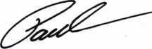

Paul Kanitra

Government Relations Manager Associated Locksmiths of America

Professional Business Products donates 5% of all sales to the ALOA Scholarship Fund!

Advertise with Weatherproof Safety Labels!

Lockout your  
competition

by placing your  
calling card on  
every door you  
service! Keep

your name in front  
of every customer  
with these Durable,  
Affordable Labels  
Call & Order Today  
1 -800-355-6322

**(Actual Label Size** 1 **1/2x4** 1/2)

Professional Business Products

ALOA Associate Member

BUYING FROM NEBS? We offer lower prices on Invoices, Checks, Business Cards, Repair Tags, Magnets, Key Tags, Pens and Labels. Come see us in Baltimore at the ALOA Security Expo Booth 854

[www.pbp2000.covn](http://www.pbp2000.covn)

Keynotes • November 2004

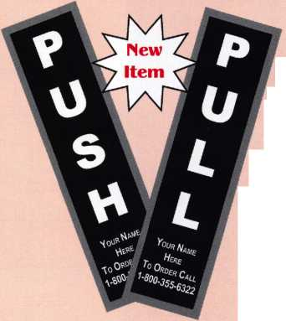

BOARD

**nominations**

**What ALOA Board Positions Are Open and Where Am I Qualified to Run?**

There are currently eight directors positions open for election in addition to the position of President. ALOA members nominate and elect the directors from their own regions. Only those who have been ALOA members for three years and are from the region are eligi­ble to run for open positions within that region. Members from any region are eligible to run for either President or Secretary; how­ever they must be a sitting board member or have served on the board of directors within the preceding three years to be eligible to run for President or Secretary.

Each Region shall be represented on the Board of Directors according to the following formula:

1. or fewer voting members - one director
2. to 2,000 voting members - two directors
3. or more voting members - three directors

The number of voting members in each Region shall be determined by the member­ship census report in effect on July 1 of the preceding year.

The following vacancies will exist for the election to be held before the ALOA 2005 convention.

**President**

**Southeast**

**North Central**

**South Central**

**Southwest**

**Asian**

**Associate**

**one position one position two positions one position two positions one position one position**

If you have any questions, please contact Charles Gibson at (800) 532-2562 or email [charlie@aloa.org](mailto:charlie@aloa.org).

On this page you will find the required nomi­nation petition and on the following page the Commitment to ALOA Board Service form.

The following is the number of signatures required for each Board position based on the July 1, 2004 ALOA membership census:

**President 25**

**Asian 3**

**Associate 2**

**North Central 12**

**South Central 7**

**Southeast 10**

**Southwest 12**

Associated Locksmiths of America, Inc.

Board of Directors Nomination Petition

Please print legibly or type. This form can be reproduced if needed.

I, the undersigned, request that, the ballot for

be placed on

(name of nominee and member number)

for the election to be held at

(position for which individual is being nominated)

the special meeting of ALOA members to be held in 2005 or any adjournment thereof. I am eligible to vote in the region.

PRINTED NAME

PRINTED NAME

PRINTED NAME

PRINTED NAME

PRINTED NAME

PRINTED NAME

PRINTED NAME

PRINTED NAME

PRINTED NAME

PRINTED NAME

PRINTED NAME

PRINTED NAME

PRINTED NAME

PRINTED NAME

PRINTED NAME

PRINTED NAME

PRINTED NAME

PRINTED NAME

PRINTED NAME

PRINTED NAME

PRINTED NAME

PRINTED NAME

PRINTED NAME

MEMBER #

SIGNATURE

YOUR COMMITMENT TO ALOA BOARD SERVICE

IPlease read carefully and sign where indicated.)

The ALOA Board governs with emphasis on organizational vision rather than on interpersonal issues of the Board; encourages diversity in viewpoints; focuses on strategic leadership rather than administrative detail; observes clear distinction between Board and Executive Director roles; makes collective rather than individual decisions; exhibits future orientation rather than past; and governs proactively rather than reactively. (For a copy of the ALOA Board of Directors Governance Policy contact the ALOA headquarters office.) The responsibilities of an ALOA board member include contributing a moderate amount of personal time, and a significant degree of professional guidance and expertise to the organization.

You will be expected to come to board meetings and the annual membership meeting. You will need to be prepared to sensibly discuss matters of great importance to your profession and participate in setting policy as part of a gov­erning body. Your course of action during your tenure on the ALOA board should be guided by fair minded, construc­tive goals pertaining to matters of consequence for ALOA and for the industry. Your contributions are expected to bene­fit ALOA as a whole, taking individual member rights and concerns into account, but free of the taint of partisan poli­tics or personal gain.

On a practical note: ALOA board members are expected to behave and dress professionally at all times, especially when actively representing the association. ALOA board members are required to participate in two board meetings per year, of three or four days in length, one each fall and spring. Board members are also asked to attend the annu­al convention and are required to attend the annual membership meeting. Board members may also be asked on a voluntary basis, to represent ALOA at related local, state or regional functions, including serving in the ALOA Booth and otherwise promoting ALOA. When travel is required for a board member, expenses covered by ALOA include lodging, travel and a reasonable per diem. The Board has stipulated that assigned travel will be reimbursed at the lesser of the 30-day advance tourist class airfare in effect at the time of travel or the current per-mile rate for travel by personal automobile. Spouse expenses, including extra room charges, etc., are the individual's responsibility.

• • •

I have read and agree to adhere to the ALOA Board of Directors Governance Policy. Furthermore I understand the above responsibilities of an ALOA board member, and agree to commit my time and energies as needed. I certify all of the information contained on this form and supporting documentation to be true and complete.

I can be contacted with questions at:

Address Phone #

Signed:

Date

Please attach a recent photograph of yourself along with a 75 word or less biography and retain a copy of this form for your own files. This form and all supporting documentation should be submitted no later than March 1, 2005.

Mail to:

Nominee Profile

Secretary of the Board of Directors  
Associated Locksmiths of America, Inc.

3003 Live Oak Street  
Dallas, TX 75204-6186  
1-800-2562

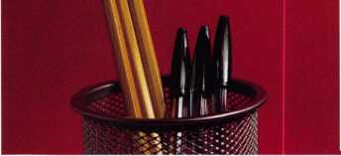

about the authors

r

You need it When?

**How about now!? :■)**



Another Special  
Value-added Benefit to your

ALOA Membership!

Click here

iL

[www.clearstar.com](http://www.clearstar.com) / ALOA

**Claire L. Cohen, CML**

Claire Cohen, the second woman to  
become a CML, has been in locksmithing  
since 1977, and has been writing articles  
for keynotes since 1987. She is also a con-  
tributing editor for Keynotes, and received  
the 2001 Keynotes Author of the Year Award  
- again. She is only the second woman to  
receive that honor.

**Merritt Perkins, RL**

Merritt Perkins, RL, has been a developing  
member of the locksmith and electronics  
industries for many years. He owns and  
operates Merritt L. Perkins Labs in Three  
Rivers, Ml.

**Greg Perry, CML, CPS**

Greg Perry, CML, CPS, has been in the locksmith industry for 20 years. He’s spent half of that time as a field technician for Security Engineering in Ridgecrest, CA. Greg is also a past president of the Desert Counties Chapter of the California Locksmiths Association. He has also won the 2002 Keynotes Author of the Year Award. You can email him at [glmperry@iwvisp.com](mailto:glmperry@iwvisp.com)

**Eric Costley, CRL**

Eric Costley, CRL has been active in the locksmith industry since 1980. He has a bachelor’s degree from Gardnre-Webb University, and has worked in shops in Arizona, North Carolina, and New York. He is currently employed by Bill’s Locksmithing in Elmira, New york. Eric’s hobbies include music and raising tarantulas.

Keynotes • November 2004

Automatic Entry into a drawing for a 36” Sony Plasma HDTV

**non 2005**

ueet Home Chicago

**Get MORE** with HLOfl’s  
Biggest Membership Driue EUER!

^ 10% discount for any lurchase at the ALOA

There is strength in numbers. MORE, means more uoices-more uoices to attract fresh

bookstore

blood. More uoices to increase consumer awareness. Rnd more uoices to speak

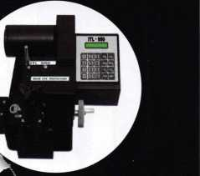

for/against new laws and regulations that affect the security industry.

Get in the game!

* Recruit 1 neuj member before December 31, 2004 and receiue $50.00 off your oiun 2005 membership dues, plus RLOR mill uiaiue the $50.00 application fee for your neiu recruit. (**completed application and dues must be submitted with your renewal to receiue credit)**
* Recruit 5 new members and recommend 5 others before June 2005 for an entry into the drawing **(drawing to be held at the RLOR Conuention and Security Expo 2005)** for a 7-Day Education and TRIPF0R2totheflloa 50th Rnniuersary Conuention in Las Degas, Neuada. **[July 2006-airfare from continental U.S. only)**

Automatic Entry into a draw- \ ing for a Key Machine (Actual model not pictured)

Here's how it works: 1) Make copies of the ALOA Membership Application form (for additional forms, call (800)532-2562, email [membership@aloa.org](mailto:membership@aloa.org), fax  
(214)827-1810 or download from <http://www.aloa.org/memapp.cfm>. 2) Recommend an industry peer by filling out this coupon (make copies first) and mail  
to ALOA, Attn. Membership Drive, 3003 Live Oak Street, Dallas, Texas 75204.

We will send your colleague an information kit with with notation that they are receiving this invitation to join per YOUR recommendation. When your  
"sponsoree" signs up, we'll send you notification so you can keep count.

Name of Sponsor (current ALOA Member)

Name of person recommended for membership

Address

City State Zip Country

Phone Fax Email

A free $10,000.00 bond  
for all active members

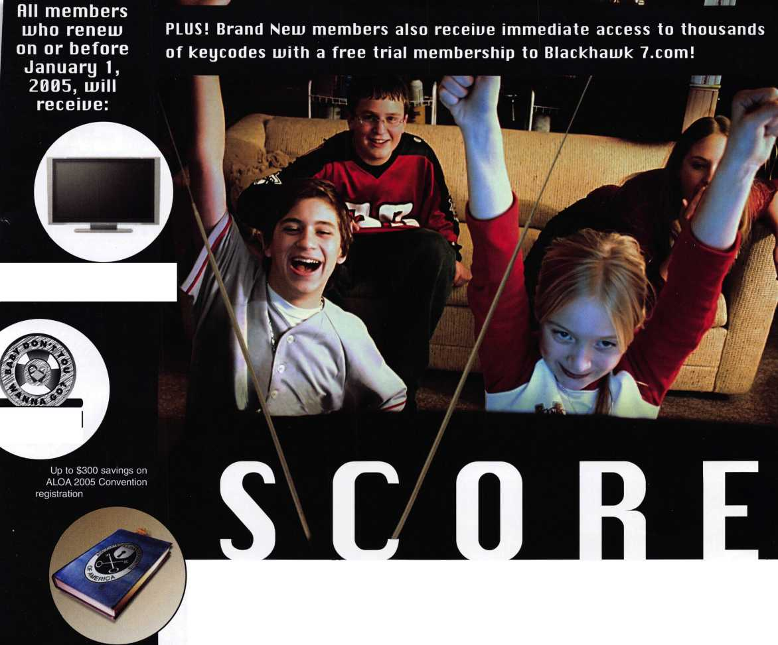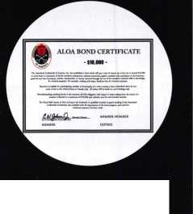

Now

ve lost my Taurus keys... m you make me a new set?1

NGS STAR XL CAN Locksmith 8008LXLC

low much of your money ave you sent to the >cal Ford Dealer?

id you Know... the Dealers charge an verageof $100 per ansponder key?

you can get the factory ansponder tool for less lan the cost of doing one By per month?

Use what the Dealers use for complete coverage on ALL Ford/Lincoln-Mercury and Mazda vehicles equipped with transponder keys. The NGS XL CAN offers complete transponder coverage including CAN protocol and the ability to clear ALL Diagnostic Service Codes

II Free Technical Support

HKiVoiniini^**-i** a **? it"r\onv**

**2004 Software Update and CAN Vehicle Interface Module now available.** i

***mot***

